SPINAL VISION CNN-DRIVEN TECHNIQUES FOR ACCURATE STENOSIS DETECTION
TABLE OF CONTENT

SL.NO | TITLE | PAGE.NO
01. | ABSTRACT
02. | EXISTING SYSTEM  2.1 DRAWBACKS
03. | INTRODUCTION  3.1 DATA SCIENCE  3.2 ARTIFICIAL INTELLIGENCE
04. | MACHINE LEARNING
05. | DEEP LEARNING
06. | PREPARING THE DATASET
07. | PROPOSED SYSTEM  7.1 ADVANTAGES
08. | LITERATURE SURVEY
09. | SYSTEM STUDY  9.1 PROJECT GOAL  9.2 OBJECTIVES  9.3 SCOPE OF THE PROJECT
10. | OUTLINE OF THE PROJECT  10.1 OVERVIEW OF THE SYSTEM
11. | PROJECT REQUIREMENT  11.1 FUNCTIONAL REQUIREMENT  11.2 NON-FUNCTIONAL REQUIREMENT
12. | FEASIBILITY STUDY  12.1 DATAFLOW DIAGRAM
13. | SYSTEM ARCHITECTURE
14. | WORKFLOW DIAGRAM
15. | USECASE DIAGRAM
16. | CLASS DIAGRAM
17. | ACTIVITY DIAGRAM
18. | SEQUENCE DIAGRAM
19. | E.R – DIAGRAM
20. | COLLABORATION DIAGRAM
21. | ENVIRONMENT REQUIREMENT
22. | SOFTWARE DESCRIPTION  22.1 ANACONDA NAVIGATOR  22.2 JUPYTER NOTEBOOK  22.3 PYCHARM
23. | PYTHON
24. | METHODOLOGY
25. | ARTIFICIAL NEURAL NETWORK (ANN)
26. | ARCHITECTURE OF CNN
27. | TYPES OF CNN  27.1 ALEX NET  27.2 RESNET
28. | LIST OF MODULES
29. | MODULE DESCRIPTION  29.1 IMPORT THE GIVEN IMAGE FROM DATASET  29.2 TO TRAIN THE MODULE BY GIVEN IMAGE DATASET  29.3 WORKING PROCESS OF LAYERS IN CNN MODEL  29.4 CLASSIFICATION IDENTIFICATION
30. | DEPLOY  30.1 DJANGO  30.2 HTML  30.3 CSS
31. | CODING
32. | CONCLUSION
33. | FUTURE WORK

LIST OF FIGURES

SL.NO | TITLE | PAGE.NO
1. | DATAFLOW DIAGRAM
2. | SYSTEM ARCHITECTURE
3. | WORKFLOW DIAGRAM
4. | USECASE DIAGRAM
5. | CLASS DIAGRAM
6. | ACTIVITY DIAGRAM
7. | SEQUENCE DIAGRAM
8. | E.R – DIAGRAM
9. | COLLABORATION DIAGRAM

LIST OF SYSMBOLS

S.NO | NOTATION  NAME | NOTATION | DESCRIPTION
1. | Class |  | Represents a collection of similar entities grouped together.
2. | Association | nAME | Associations represents static relationships between classes. Roles represents the way the two classes see each other.
3. | Actor |  | It aggregates several classes into a single classes.
4. | Aggregation |  | Interaction between the system and external environment

5. | Relation  (uses) | uses | Used for additional process communication.
6. | Relation  (extends) | EXTENDS | Extends relationship is used when one use case is similar to another use case but does a bit more.
7. | Communication |  | Communication between various use cases.
8. | State |  | State of the process.
9. | Initial State |  | Initial state of the object
10. | Final state |  | Final state of the object
11. | Control flow |  | Represents various control flow between the states.
12. | Decision box |  | Represents decision making process from a constraint
13. | Usecase |  | Interact ion between the system and external environment.

14. | Component |  | Represents physical modules which is a collection of components.
15. | Node |  | Represents physical modules which are a collection of components.
16. | Data Process/State |  | A circle in DFD represents a state or process which has been triggered due to some event or acion.
17. | External entity |  | Represents external entities such as keyboard,sensors,etc.
18. | Transition |  | Represents communication that occurs between processes.
19. | Object Lifeline |  | Represents the vertical dimensions that the object communications.
20. | Message | Message | Represents the message exchanged.

SPINAL VISION CNN-DRIVEN TECHNIQUES FOR ACCURATE STENOSIS DETECTION

ABSTRACT:
Spinal lumbar stenosis is a prevalent degenerative condition affecting the spinal canal, leading to compression of neural structures and subsequent symptoms such as pain and reduced mobility. Accurate and timely classification of lumbar stenosis stages is crucial for effective treatment planning and patient management. This study proposes a novel approach employing Convolutional Neural Network (CNN) techniques for the automated detection and classification of spinal lumbar stenosis stages. The proposed CNN-based framework utilizes advanced image processing and deep learning methodologies to analyse medical imaging data, such as magnetic resonance imaging (MRI) and computed tomography (CT) scans. The convolutional layers of the network are designed to automatically extract hierarchical features from the input images, capturing intricate patterns associated with different stages of lumbar stenosis. The model is trained on a diverse dataset encompassing various degrees of stenosis severity, ensuring robust generalization to unseen cases. The research focuses on achieving high accuracy, sensitivity, and specificity in classifying lumbar stenosis stages, thereby assisting healthcare professionals in making informed decisions about patient care. The results obtained from the proposed CNN-based classification system are compared with existing methods to validate its efficacy and superiority in terms of diagnostic performance. This study not only contributes to the field of medical image analysis but also addresses the pressing need for accurate and efficient tools for lumbar stenosis stage classification. The integration of deep learning techniques in this context holds promising potential for enhancing diagnostic capabilities and streamlining treatment strategies, ultimately improving patient outcomes in the management of spinal lumbar stenosis.

EXISTING SYSTEM:
Locomotion disorder caused by spinal cord injury (SCI) leads to a considerably decreased quality of people’s lives. Although there are no known cure methods for SCI, a lower extremity exoskeleton (LEE) has a perspective to restore the locomotion ability of SCI patients. Statistics show that the number of published articles on LEEs has exponentially increased over the past 20 years; however, no reviews have been conducted to summarize these studies comprehensively. To fill up this open gap, a comprehensive review from engineering to clinical standpoint is carried out, which is based on the preferred reporting items for systematic reviews and meta-analyses’ methods, including their structural designs, drive forms, control methods, and clinical assessments. A systematic discussion among them is performed while considering the main scientific and technical aspects. The analysis indicates that the actuator configuration, motor selection, state transition, trajectory tracking, transparency implementation, and clinical factor design in exoskeleton development are full of challenges, which should be investigated in more technical efforts in the future.

PROBLEM STATEMENTS:

- They did not implement the deployment process
- They implemented simple method. They did not Implement Convolution neural network and artificial neural network.
- They did not do image preprocessing process.
- They did not do data analysis process by using Plot and Graphs.
- They did not compared more than an architecture to getting better accuracy level.
- They are only found spinal Spinal Cord Injury
- They did not train the training data to computer properly.

INTRODUCTION
The detection and classification of spinal lumbar stenosis stages represent a critical area in medical imaging, where accurate diagnosis plays a pivotal role in effective patient care. This study employs Convolutional Neural Network (CNN) techniques, a subset of deep learning, to enhance the precision and efficiency of spinal lumbar stenosis identification. By leveraging the advanced pattern recognition capabilities of CNNs, the proposed methodology aims to automate the classification of different stenosis stages based on medical imaging data. This innovative approach not only streamlines the diagnostic process but also holds the potential to improve overall patient outcomes by facilitating timely and accurate treatment interventions tailored to specific stenosis severity levels.
PROPOSED SYSTEM:
The proposed system for the detection and classification of spinal lumbar stenosis stages utilizes advanced Convolutional Neural Network (CNN) techniques to enhance diagnostic accuracy and streamline patient care. Leveraging the power of deep learning, this innovative approach aims to categorize different stages of lumbar stenosis with a high degree of precision, providing healthcare professionals with valuable insights for tailored treatment plans. The CNN architecture employed in this system is designed to analyze medical imaging data, such as MRIs and CT scans, allowing for automated and efficient identification of lumbar stenosis severity. By harnessing the capabilities of neural networks, the proposed system contributes to a more nuanced understanding of spinal health, facilitating early intervention and personalized medical interventions. This technology represents a significant stride toward improving diagnostic capabilities in the field of orthopedics, ultimately enhancing patient outcomes and quality of care.

PROBLEM STATEMENTS SOLUTIONS:

- We implemented the deployment process by using Frontend codes like Html, Css, Bootstrap and Python Framework like Django or Flask.
- We implemented image preprocessing process by using Rescale, Horizontal flip, Shear range and Zoom range.
- We implemented data analysis process by using Plot and Graphs.
- We compared more than a two architecture to getting better accuracy level.
- We classify into 4 Spine stenosis disease. The proposed system leverages deep learning (CNN architectures) to automatically extract and analyse patterns in spine stenosis images.

- We figure out performance metrics value properly.
- We improved the accuracy level and performance level.
- We implemented Convolution neural network and artificial neural network concept properly.
- We did train the training data to computer properly. We implemented the test data to testing the output values.

Domain overview:
4.1 Data Science:
Data science is an interdisciplinary field that uses scientific methods, processes, algorithms and systems to extract knowledge and insights from structured and unstructured data, and apply knowledge and actionable insights from data across a broad range of application domains.
The term "data science" has been traced back to 1974, when Peter Naur proposed it as an alternative name for computer science. In 1996, the International Federation of Classification Societies became the first conference to specifically feature data science as a topic. However, the definition was still in flux.
The term “data science” was first coined in 2008 by D.J. Patil, and Jeff Hammerbacher, the pioneer leads of data and analytics efforts at LinkedIn and Facebook. In less than a decade, it has become one of the hottest and most trending professions in the market.
Data science is the field of study that combines domain expertise, programming skills, and knowledge of mathematics and statistics to extract meaningful insights from data.
Data science can be defined as a blend of mathematics, business acumen, tools, algorithms and machine learning techniques, all of which help us in finding out the hidden insights or patterns from raw data which can be of major use in the formation of big business decisions.

Data Scientist:
Data scientists examine which questions need answering and where to find the related data. They have business acumen and analytical skills as well as the ability to mine, clean, and present data. Businesses use data scientists to source, manage, and analyze large amounts of unstructured data.
Required Skills for a Data Scientist:
- Programming: Python, SQL, Scala, Java, R, MATLAB.
- Machine Learning: Natural Language Processing, Classification, Clustering.
- Data Visualization: Tableau, SAS, D3.js, Python, Java, R libraries.
- Big data platforms: MongoDB, Oracle, Microsoft Azure, Cloudera.

  - DEEP LEARNING
Deep learning is a branch of machine learning which is completely based on artificial neural networks, as neural network is going to mimic the human brain so deep learning is also a kind of mimic of human brain. It’s on hype nowadays because earlier we did not have that much processing power and a lot of data. A formal definition of deep learning is- neurons Deep learning is a particular kind of machine learning that achieves great power and flexibility by learning to represent the world as a nested hierarchy of concepts, with each concept defined in relation to simpler concepts, and more abstract representations computed in terms of less abstract ones. In brain approximately 100 billion neurons all together this is a picture of an individual neuron and each neuron is connected through thousands of their neighbors. The question here is how it recreates these neurons in a computer. So, it creates an artificial structure called an artificial neural net where we have nodes or neurons. It has some neurons for input value and some for output value and in between, there may be lots of neurons interconnected in the hidden layer.
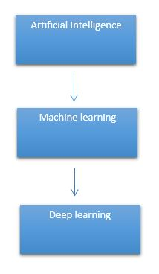

It need to identify the actual problem in order to get the right solution and it should be understood, the feasibility of the Deep Learning should also be checked (whether it should fit Deep Learning or not). It needs to identify the relevant data which should correspond to the actual problem and should be prepared accordingly. Choose the Deep Learning Algorithm appropriately. Algorithm should be used while training the dataset. Final testing should be done on the dataset
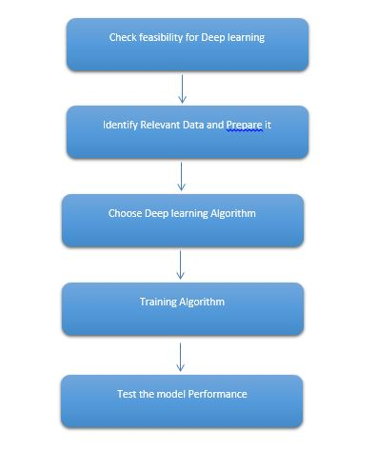
Deep learning (also known as deep structured learning) is part of a broader family of machine learning methods based on artificial neural networks with representation learning. Learning can be supervised, semi-supervised or unsupervised.
Deep-learning architectures such as deep neural networks, deep belief networks, deep reinforcement learning, recurrent neural networks and convolutional neural networks have been applied to fields including computer vision, speech recognition, natural language processing, machine translation, bioinformatics, drug design, medical image analysis, material inspection and board game programs, where they have produced results comparable to and in some cases surpassing human expert performance.
Artificial neural networks (ANNs) were inspired by information processing and distributed communication nodes in biological systems. ANNs have various differences from biological brains. Specifically, neural networks tend to be static and symbolic, while the biological brain of most living organisms is dynamic (plastic) and analogue.
The adjective "deep" in deep learning refers to the use of multiple layers in the network. Early work showed that a linear perceptron cannot be a universal classifier, but that a network with a non-polynomial activation function with one hidden layer of unbounded width can. Deep learning is a modern variation which is concerned with an unbounded number of layers of bounded size, which permits practical application and optimized implementation, while retaining theoretical universality under mild conditions. In deep learning the layers are also permitted to be heterogeneous and to deviate widely from biologically informed connectionist models, for the sake of efficiency, trainability and understandability, whence the "structured" part.
Deep learning is a class of machine learning algorithms that uses multiple layers to progressively extract higher-level features from the raw input. For example, in image processing, lower layers may identify edges, while higher layers may identify the concepts relevant to a human such as digits or letters or faces.
Interpretations:
Deep neural networks are generally interpreted in terms of the universal approximation theorem or probabilistic inference.
The classic universal approximation theorem concerns the capacity of feed-forward neural networks with a single hidden layer of finite size to approximate continuous functions. In 1989, the first proof was published by George Cybenko for sigmoid activation functions and was generalised to feed-forward multi-layer architectures in 1991 by Kurt Hornik. Recent work also showed that universal approximation also holds for non-bounded activation functions such as the rectified linear unit.
The universal approximation theorem for deep neural networks concerns the capacity of networks with bounded width but the depth is allowed to grow proved that if the width of a deep neural network with ReLU activation is strictly larger than the input dimension, then the network can approximate any Lebesgue integrable function; If the width is smaller or equal to the input dimension, then deep neural network is not a universal approximator.
The probabilistic interpretation derives from the field of machine learning. It features inference, as well as the optimization concepts of training and testing, related to fitting and generalization, respectively. More specifically, the probabilistic interpretation considers the activation nonlinearity as a cumulative distribution function. The probabilistic interpretation led to the introduction of dropout as regularizer in neural networks. The probabilistic interpretation was introduced by researchers including Hopfield, Widrow and Narendra and popularized in surveys such as the one by Bishop.

Deep learning revolution:

In 2012, a team led by George E. Dahl won the "Merck Molecular Activity Challenge" using multi-task deep neural networks to predict the biomolecular target of one drug. In 2014, Hochreiter's group used deep learning to detect off-target and toxic effects of environmental chemicals in nutrients, household products and drugs and won the "Tox21 Data Challenge" of NIH, FDA and NCATS.
Significant additional impacts in image or object recognition were felt from 2011 to 2012. Although CNNs trained by back-propagation had been around for decades, and GPU implementations of NNs for years, including CNNs, fast implementations of CNNs on GPUs were needed to progress on computer vision. In 2011, this approach achieved for the first time superhuman performance in a visual pattern recognition contest. Also in 2011, it won the ICDAR Chinese handwriting contest, and in May 2012, it won the ISBI image segmentation contest. Until 2011, CNNs did not play a major role at computer vision conferences, but in June 2012, a paper by Ciresan et al. at the leading conference CVPR showed how max-pooling CNNs on GPU can dramatically improve many vision benchmark records.
In October 2012, a similar system by Krizhevsky et al. won the large-scale ImageNet competition by a significant margin over shallow machine learning methods. In November 2012, Ciresan et al.'s system also won the ICPR contest on analysis of large medical images for cancer detection, and in the following year also the MICCAI Grand Challenge on the same topic. In 2013 and 2014, the error rate on the ImageNet task using deep learning was further reduced, following a similar trend in large-scale speech recognition.
Image classification was then extended to the more challenging task of generating descriptions (captions) for images, often as a combination of CNNs and LSTMs.
Some researchers state that the October 2012 ImageNet victory anchored the start of a "deep learning revolution" that has transformed the AI industry.
In March 2019, Yoshua Bengio, Geoffrey Hinton and Yann LeCun were awarded the Turing Award for conceptual and engineering breakthroughs that have made deep neural networks a critical component of computing.

- LITERATURE SURVEY
General
A literature review is a body of text that aims to review the critical points of current knowledge on and/or methodological approaches to a particular topic. It is secondary sources and discuss published information in a particular subject area and sometimes information in a particular subject area within a certain time period.
Its ultimate goal is to bring the reader up to date with current literature on a topic and forms the basis for another goal, such as future research that may be needed in the area and precedes a research proposal and may be just a simple summary of sources. Usually, it has an organizational pattern and combines both summary and synthesis.
A summary is a recap of important information about the source, but a synthesis is a re-organization, reshuffling of information. It might give a new interpretation of old material or combine new with old interpretations or it might trace the intellectual progression of the field, including major debates. Depending on the situation, the literature review may evaluate the sources and advise the reader on the most pertinent or relevant of them. Loan default trends have been long studied from a socio-economic stand point.
Most economics surveys believe in empirical modeling of these complex systems in order to be able to predict the loan default rate for a particular individual. The use of machine learning for such tasks is a trend which it is observing now. Some of the survey’s to understand the past and present perspective of loan approval or not.

Review of Literature Survey
Title : Artificial intelligence and machine learning in spine research
Author : Fabio Galbusera | Gloria Casaroli | Tito Bassani
Year : 2018
Artificial intelligence (AI) and machine learning (ML) techniques are revolutionizing several industrial and research fields like computer vision, autonomous driving, natural language processing, and speech recognition. These novel tools are already having a major impact in radiology, diagnostics, and many other fields in which the availability of automated solution may benefit the accuracy and repeatability of the execution of critical tasks. In this narrative review, we first present a brief description of the various techniques that are being developed nowadays, with special focus on those used in spine research. Then, we describe the applications of AI and ML to problems related to the spine which have been published so far, including the localization of vertebrae and discs in radiological images, image segmentation, computer-aided diagnosis, prediction of clinical outcomes and complications, decision support systems, content-based image retrieval, biomechanics, and motion analysis. Finally, we briefly discuss major ethical issues related to the use of AI in healthcare, namely, accountability, risk of biased decisions as well as data privacy and security, which are nowadays being debated in the scientific community and by regulatory agencies.

Title : Clinical, Kinematic and Muscle Assessment of Bilateral Coordinated Upper-Limb Movements Following Cervical Spinal Cord Injury
Author : Amy Bellitto , Alice De Luca, Simona Gamba, Luca Losio, Antonino Massone, Maura Casadio , and Camilla Pierella
Year : 2023
— Cervical spinal cord injury (cSCI) often results in bilateral impairment of the arms, leading to difficulties in performing daily activities. However, little is known about the neuromotor alterations that affect the ability of individuals with cSCI to perform coordinated movements with both arms. To address this issue, we developed and tested a functional assessment that integrates clinical, kinematic, and muscle activity measures, including the evaluation of bilateral arm movements. Twelve subjects with a C5-C7 spinal lesion and six unimpaired subjects underwent an evaluation that included three tests: the Manual Muscle Test, Range Of Motion test and Arm stabilisation test, a subsection of the “Van Lieshout arm/hand function test”. During the latter, we recorded kinematic and muscle activity data from the upper-body during the execution of a set of movements that required participants to stabilize both arms against gravity at different config urations. Analytical methods, including muscle synergies, spinal maps, and Principal Component Analysis, were used to analyse the data. Clinical tests detected limitations in shoulder abduction-flexion of cSCI participants and alterations in elbows-wrists motor function. The instrumented assessment provided insight into how these limitations impacted the ability of cSCI participants to perform bilateral movements. They exhibited severe difficulty in performing movements involving over-the-shoulder motion and shoulder internal rotation due to altered patterns of activity of the scapular stabilizer muscles, latissimus dorsi, pectoralis, and triceps. Our findings shed light on the bilateral neuromotor changes that occur post-cSCI addressing not only motor deficits, but also the underlying abnormal, weak, or silent muscle activations.
Title : DXplorer: A Unified Visualization Framework for Interactive Dendritic Spine Analysis Using 3D Morphological Features
Author : JunYoung Choi , Sang-Eun Lee , YeIn Lee, Eunji Cho , Sunghoe Chang , and Won-Ki Jeong
Year : 2023
—Dendritic spines are dynamic, submicron-scale protrusions on neuronal dendrites that receive neuronal inputs. Morphological changes in the dendritic spine often reflect alterations in physiological conditions and are indicators of various neuropsychiatric conditions. However, owing to the highly dynamic and heterogeneous nature of spines, accurate measurement and objective analysis of spine morphology are major challenges in neuroscience research. Most conventional approaches for analyzing dendritic spines are based on two-dimensional (2D) images, which barely reflect the actual three-dimensional (3D) shapes. Although some recent studies have attempted to analyze spines with various 3D-based features, it is still difficult to objectively categorize and analyze spines based on 3D morphology. Here, we propose a unified visualization framework for an interactive 3D dendritic spine analysis system, DXplorer, that displays 3D rendering of spines and plots the high-dimensional features extracted from the 3D mesh of spines. With this system, users can perform the clustering of spines interactively and explore and analyze dendritic spines based on high-dimensional features. We propose a series of high-dimensional morphological features extracted from a 3D mesh of dendritic spines. In addition, an interactive machine learning classifier with visual exploration and user feedback using an interactive 3D mesh grid view ensures a more precise classification based on the spine phenotype. A user study and two case studies were conducted to quantitatively verify the performance and usability of the DXplorer. We demonstrate that the system performs the entire analytic process effectively and provides high-quality, accurate, and objective analysis.
Title : Data-driven diagnosis of spinal abnormalities using feature selection and machine learning algorithms
Author : Md. Raihan-Al-MasudID, M. Rubaiyat Hossain MondalID
Year : 2020
This paper focuses on the application of machine learning algorithms for predicting spinal abnormalities. As a data preprocessing step, univariate feature selection as a filter based feature selection, and principal component analysis (PCA) as a feature extraction algorithm are considered. A number of machine learning approaches namely support vector machine (SVM), logistic regression (LR), bagging ensemble methods are considered for the diagnosis of spinal abnormality. The SVM, LR, bagging SVM and bagging LR models are applied on a dataset of 310 samples publicly available in Kaggle repository. The performance of classification of abnormal and normal spinal patients is evaluated in terms of a number of factors including training and testing accuracy, recall, and miss rate. The classifier models are also evaluated by optimizing the kernel parameters, and by using the results of receiver operating characteristic (ROC) and precision-recall curves. Results indicate that when 78% data are used for training, the observed training accuracies for SVM, LR, bagging SVM and bagging LR are 86.30%, 85.47%, 86.72% and 85.06%, respectively. On the other hand, the accuracies for the test dataset for SVM, LR, bagging SVM and bagging LR are the same being 86.96%. However, bagging SVM is the most attractive as it has a higher recall value and a lower miss rate compared to others. Hence, bagging SVM is suitable for the classification of spinal patients when applied on the most five important features of spinal samples.
Title : Current Applications of Machine Learning in Spine: From Clinical View
Author : PeiYang Wang, MD1 , Wei Zhang, MS1 , Yong Huang, MD1 , YunTao Wang, PhD3 , and XiaoTao Wu, MD
Year : 2020

Study Design: Narrative review. Objectives: This review aims to present current applications of machine learning (ML) in spine domain to clinicians. Methods: We conducted a comprehensive PubMed search of peer-reviewed articles that were published between 2006 and 2020 using terms (spine, spinal, lumbar, cervical, thoracic, machine learning) to examine ML in spine. Then exclude research of other domain, case report, review or meta-analysis, and which without available abstract or full text. Results: Total 1738 articles were retrieved from database, and 292 studies were finally included. Key findings of current applications were compiled and summarized in this review. Main clinical applications of those techniques including image processing, diagnosis, decision supporting, operative assistance, rehabilitation, surgery outcomes, complications, hospitalization and cost. Conclusions: ML had achieved excellent performance and hold immense potential in spine. ML could help clinical staff to improve medical level, enhance work efficiency, and reduce adverse events. However more randomized controlled trials and improvement of interpretability are essential to clinicians accepting models’ assistance in real work

SYSTEM STUDY

Aim:

This study aims to implement Convolutional Neural Network (CNN) architectures for accurate and automated classification of spine stenosis in medical imaging.

Objectives:
The objective of detecting and classifying stages of spinal lumbar stenosis using Convolutional Neural Network (CNN) techniques is to enhance the accuracy and efficiency of diagnosis in this medical condition. Spinal lumbar stenosis is a prevalent disorder characterized by the narrowing of the spinal canal, often leading to debilitating symptoms. The application of CNNs in medical image analysis enables automated and precise recognition of specific patterns and features indicative of different stages of lumbar stenosis. This approach aims to provide clinicians with a reliable tool for early detection, classification, and personalized treatment planning, ultimately improving patient outcomes by facilitating timely interventions and reducing the risk of complications associated with this spinal disorder.

Scope:
The detection of spinal lumbar stenosis stages through Convolutional Neural Network (CNN) techniques holds promising prospects in the field of medical image analysis. By leveraging advanced deep learning methodologies, this approach allows for automated and accurate classification of different stages of spinal lumbar stenosis, providing a more efficient and objective diagnostic tool. CNNs excel in extracting intricate features from medical images, enabling the model to discern subtle variations in spinal structures indicative of different stenosis stages. This technology not only enhances the speed and precision of diagnosis but also has the potential to assist healthcare professionals in tailoring appropriate treatment plans for patients based on the severity of their condition. As a result, the application of CNN techniques in the detection and classification of spinal lumbar stenosis stages represents a significant stride towards improving patient care and diagnostic efficiency in the realm of spinal disorders.

OUTLINE OF THE PROJECT

Overview of the system:
- Define a problem
- Gathering image data set
- Evaluating algorithms
- Detecting results
The steps involved in Building the data model is depicted below.

Data collection (Splitting Training set & Test) set)

Pre Processing (Sequential)

Building classification Model

The detection of spinal stenosis

Fig: data flow diagram for CNN model

- PROJECT REQUIREMENTS
General:
Requirements are the basic constrains that are required to develop a system. Requirements are collected while designing the system. The following are the requirements that are to be discussed.
1. Functional requirements
2. Non-Functional requirements
3. Environment requirements
A. Hardware requirements
B. software requirements

9.1 Functional requirements:
The software requirements specification is a technical specification of requirements for the software product. It is the first step in the requirements analysis process. It lists requirements of a particular software system. The following details to follow the special libraries like tensorflow, keras, matplotlib.

9.2 Non-Functional Requirements:
Process of functional steps,
- Problem define
- Preparing data
- Evaluating algorithm
- Improving results
- Prediction the result

Environment Requirements:
1. Software Requirements:
Operating System : Windows / Linux
Simulation Tool : Anaconda with Jupyter Notebook

2. Hardware requirements:
Processor : Pentium IV/III
Hard disk : minimum 80 GB
RAM : minimum 2 GB

- FEASIBILITY STUDY
Splitting the dataset:
The data use is usually split into training data and test data. The training set contains a known output and the model learns on this data in order to be generalized to other data later on. It has the test dataset (or subset) in order to test our models and it will do this using Tensor flow library in Python using the Keras method.

Construction of a Detecting Model:

Deep learning needs data gathering have lot of past image data’s. Training and testing this model working and predicting correctly.
Data Gathering
CNN Algorithm
Train model

Prediction
Test model

Fig: Steps of dataflow diagram

DESIGN ARCHITECTURE

General

Design is meaningful engineering representation of something that is to be built. Software design is a process design is the perfect way to accurately translate requirements in to a finished software product. Design creates a representation or model, provides detail about software data structure, architecture, interfaces and components that are necessary to implement a system.

Data Flow Diagram:
Image Details
Test dataset
Pre-processing
The detection of spinal stenosis
Training dataset
CNN Algorithm

Fig: Process of dataflow diagram

A data flow diagram (DFD) is a graphical representation of the "flow" of data through an information system, modeling its process aspects. A DFD is often used as a preliminary step to create an overview of the system without going into great detail, which can later be elaborated. DFDs can also be used for the visualization of data processing (structured design). A DFD shows what kind of information will be input to and output from the system, how the data will advance through the system, and where the data will be stored. It does not show information about process timing or whether processes will operate in sequence or in parallel, unlike a traditional structured flowchart which focuses on control flow, or a UML activity workflow diagram, which presents both control and data flows as a unified model. Data flow diagrams are also known as bubble charts. DFD is a designing tool used in the top down approach to Systems Design. Symbols and Notations Used in DFDs Using any convention’s DFD rules or guidelines, the symbols depict the four components of data flow diagrams.
External entity: an outside system that sends or receives data, communicating with the system being diagrammed. They are the sources and destinations of information entering or leaving the system. They might be an outside organization or person, a computer system or a business system. They are also known as terminators, sources and sinks or actors. They are typically drawn on the edges of the diagram.
Process: any process that changes the data, producing an output. It might perform computations, or sort data based on logic, or direct the data flow based on business rules.
Data store: files or repositories that hold information for later use, such as a database table or a membership form.
Data flow: the route that data takes between the external entities, processes and data stores. It portrays the interface between the other components and is shown with arrows, typically labeled with a short data name, like “Billing details.”
DFD levels and layers A data flow diagram can dive into progressively more detail by using levels and layers, zeroing in on a particular piece. DFD levels are numbered 0, 1 or 2, and occasionally go to even Level 3 or beyond. The necessary level of detail depends on the scope of what you are trying to accomplish. DFD Level 0 is also called a Context Diagram. It’s a basic overview of the whole system or process being analyzed or modeled. It’s designed to be an at-a-glance view, showing the system as a single high-level process, with its relationship to external entities. It should be easily understood by a wide audience, including stakeholders, business analysts, data analysts and developers.

System Architecture:

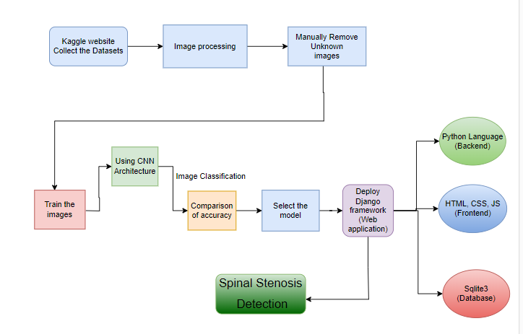

Work flow diagram:

Source images

Testing Dataset
Training Dataset

CNN algorithm

Detection of spinal stenosis Classification

Fig: Workflow Diagram

USECASE DIAGRAM:
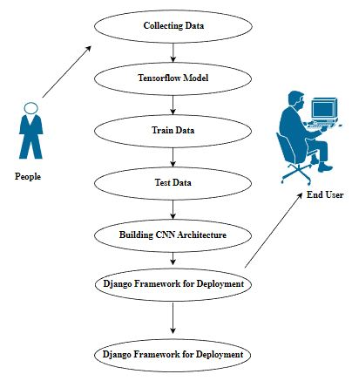

Use case diagrams are considered for high level requirement analysis of a system. So when the requirements of a system are analyzed the functionalities are captured in use cases. So, it can say that uses cases are nothing but the system functionalities written in an organized manner.

CLASS DIAGRAM:
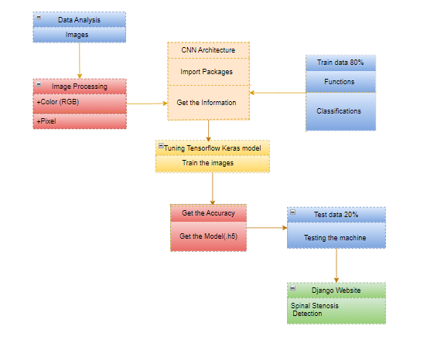

Class diagram is basically a graphical representation of the static view of the system and represents different aspects of the application. So a collection of class diagrams represent the whole system. The name of the class diagram should be meaningful to describe the aspect of the system. Each element and their relationships should be identified in advance Responsibility (attributes and methods) of each class should be clearly identified for each class minimum number of properties should be specified and because, unnecessary properties will make the diagram complicated. Use notes whenever required to describe some aspect of the diagram and at the end of the drawing it should be understandable to the developer/coder. Finally, before making the final version, the diagram should be drawn on plain paper and rework as many times as possible to make it correct.
ACTIVITY DIAGRAM:

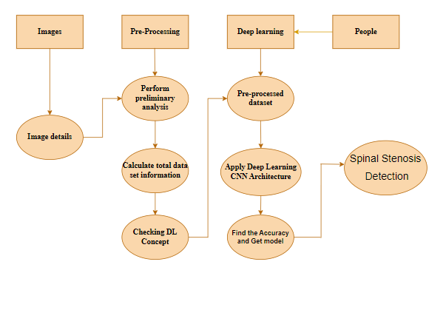

Activity is a particular operation of the system. Activity diagrams are not only used for visualizing dynamic nature of a system but they are also used to construct the executable system by using forward and reverse engineering techniques. The only missing thing in activity diagram is the message part. It does not show any message flow from one activity to another. Activity diagram is some time considered as the flow chart. Although the diagrams looks like a flow chart but it is not. It shows different flow like parallel, branched, concurrent and single.
SEQUENCE DIAGRAM:

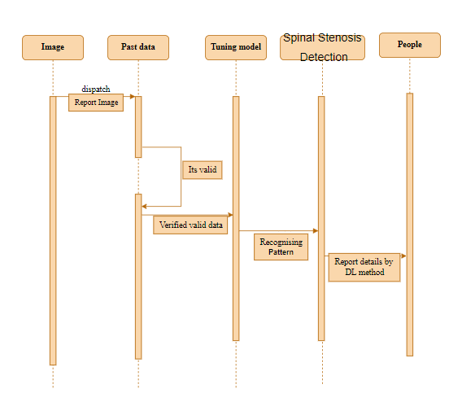
sequence diagrams model the flow of logic within your system in a visual manner, enabling you both to document and validate your logic, and are commonly used for both analysis and design purposes. Sequence diagrams are the most popular UML artifact for dynamic modelling, which focuses on identifying the behaviour within your system. Other dynamic modelling techniques include activity diagramming, communication diagramming, timing diagramming, and interaction overview diagramming. Sequence diagrams, along with class diagrams and physical data models are in my opinion the most important design-level models for modern business application development.
ER DIAGRAM:
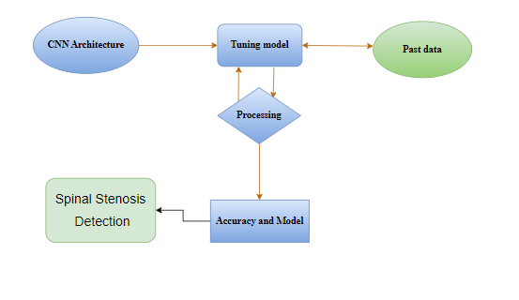

An entity relationship diagram (ERD), also known as an entity relationship model, is a graphical representation of an information system that depicts the relationships among people, objects, places, concepts or events within that system. An ERD is a data modeling technique that can help define business processes and be used as the foundation for a relational database. Entity relationship diagrams provide a visual starting point for database design that can also be used to help determine information system requirements throughout an organization. After a relational database is rolled out, an ERD can still serve as a referral point, should any debugging or business process re-engineering be needed later.

COLLABORATION DIAGRAM:

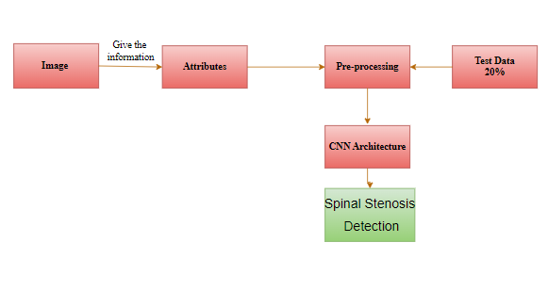

A collaboration diagram show the objects and relationships involved in an interaction, and the sequence of messages exchanged among the objects during the interaction.
The collaboration diagram can be a decomposition of a class, class diagram, or part of a class diagram.it can be the decomposition of a use case, use case diagram, or part of a use case diagram.
The collaboration diagram shows messages being sent between classes and object (instances). A diagram is created for each system operation that relates to the current development cycle (iteration).

SOFTWARE DESCRIPTION
Anaconda is a free and open-source distribution of the Python and R programming languages for scientific computing (data science, machine learning applications, large-scale data processing, predictive analytics, etc.), that aims to simplify package management and deployment. Package versions are managed by the package management system “Conda”. The Anaconda distribution is used by over 12 million users and includes more than 1400 popular data-science packages suitable for Windows, Linux, and MacOS. So, Anaconda distribution comes with more than 1,400 packages as well as the Conda package and virtual environment manager called Anaconda Navigator and it eliminates the need to learn to install each library independently. The open source packages can be individually installed from the Anaconda repository with the conda install command or using the pip install command that is installed with Anaconda. Pip packages provide many of the features of conda packages and in most cases they can work together. Custom packages can be made using the conda build command, and can be shared with others by uploading them to Anaconda Cloud, PyPI or other repositories. The default installation of Anaconda2 includes Python 2.7 and Anaconda3 includes Python 3.7. However, you can create new environments that include any version of Python packaged with conda.

ANACONDA NAVIGATOR:
Anaconda Navigator is a desktop graphical user interface (GUI) included in Anaconda® distribution that allows you to launch applications and easily manage conda packages, environments, and channels without using command-line commands. Navigator can search for packages on Anaconda.org or in a local Anaconda Repository.
Anaconda. Now, if you are primarily doing data science work, Anaconda is also a great option. Anaconda is created by Continuum Analytics, and it is a Python distribution that comes preinstalled with lots of useful python libraries for data science.
Anaconda is a distribution of the Python and R programming languages for scientific computing (data science, machine learning applications, large-scale data processing, predictive analytics, etc.), that aims to simplify package management and deployment.
In order to run, many scientific packages depend on specific versions of other packages. Data scientists often use multiple versions of many packages and use multiple environments to separate these different versions.
The command-line program conda is both a package manager and an environment manager. This helps data scientists ensure that each version of each package has all the dependencies it requires and works correctly.
Navigator is an easy, point-and-click way to work with packages and environments without needing to type conda commands in a terminal window. You can use it to find the packages you want, install them in an environment, run the packages, and update them – all inside Navigator.

The following applications are available by default in Navigator:
- JupyterLab
- Jupyter Notebook
- Spyder
- PyCharm
- VSCode
- Glueviz
- Orange 3 App
- RStudio
- Anaconda Prompt (Windows only)
- Anaconda PowerShell (Windows only)

Anaconda Navigator is a desktop graphical user interface (GUI) included in Anaconda distribution.
Navigator allows you to launch common Python programs and easily manage conda packages, environments, and channels without using command-line commands. Navigator can search for packages on Anaconda Cloud or in a local Anaconda Repository.
Anaconda comes with many built-in packages that you can easily find with conda list on your anaconda prompt. As it has lots of packages (many of which are rarely used), it requires lots of space and time as well. If you have enough space, time and do not want to burden yourself to install small utilities like JSON, YAML, you better go for Anaconda.

File Extension: An IPYNB file is a notebook document created by Jupyter Notebook, an interactive computational environment that helps scientists manipulate and analyze data using Python.

JUPYTER Notebook App: The Jupyter Notebook App is a server-client application that allows editing and running notebook documents via a web browser. The Jupyter Notebook App can be executed on a local desktop requiring no internet access (as described in this document) or can be installed on a remote server and accessed through the internet.
In addition to displaying/editing/running notebook documents, the Jupyter Notebook App has a “Dashboard” (Notebook Dashboard), a “control panel” showing local files and allowing to open notebook documents or shutting down their kernels.

kernel: A notebook kernel is a “computational engine” that executes the code contained in a Notebook document. The ipython kernel, referenced in this guide, executes python code. Kernels for many other languages exist (official kernels).
When you open a Notebook document, the associated kernel is automatically launched. When the notebook is executed (either cell-by-cell or with menu Cell -> Run All), the kernel performs the computation and produces the results. Depending on the type of computations, the kernel may consume significant CPU and RAM. Note that the RAM is not released until the kernel is shut-down

Notebook Dashboard: The Notebook Dashboard is the component which is shown first when you launch Jupyter Notebook App. The Notebook Dashboard is mainly used to open notebook documents, and to manage the running kernels (visualize and shutdown).
The Notebook Dashboard has other features similar to a file manager, namely navigating folders and renaming/deleting files

Working Process:
- Download and install anaconda and get the most useful package for machine learning in Python.
- Load a dataset and understand its structure using statistical summaries and data visualization.
- Machine learning models, pick the best and build confidence that the accuracy is reliable.

Python is a popular and powerful interpreted language. Unlike R, Python is a complete language and platform that you can use for both research and development and developing production systems. There are also a lot of modules and libraries to choose from, providing multiple ways to do each task. It can feel overwhelming.

The best way to get started using Python for machine learning is to complete a project.
- It will force you to install and start the Python interpreter (at the very least).
- It will give you a bird’s eye view of how to step through a small project.
- It will give you confidence, maybe to go on to your own small projects.

When you are applying machine learning to your own datasets, you are working on a project. A machine learning project may not be linear, but it has a number of well-known steps:
- Define Problem.
- Prepare Data.
- Evaluate Algorithms.
- Improve Results.
- Present Results.

The best way to really come to terms with a new platform or tool is to work through a machine learning project end-to-end and cover the key steps. Namely, from loading data, summarizing data, evaluating algorithms and making some predictions.
Here is an overview of what we are going to cover:
- Installing the Python anaconda platform.
- Loading the dataset.
- Summarizing the dataset.
- Visualizing the dataset.
- Evaluating some algorithms.
- Making some predictions.

VS CODE:
Visual Studio Code (VS Code) is a versatile, free, and open-source code editor developed by Microsoft. It offers a wide range of features and extensions, making it a popular choice among developers for various programming languages and development tasks.

VS Code Features:
1. Extensibility: VS Code's extensive library of extensions allows developers to customize and enhance their coding experience with various languages, tools, and frameworks.
2. Intelligent Coding Assistance: It provides smart code completion, real-time error checking, and quick-fix suggestions to boost productivity.
3. Integrated Terminal: With an integrated terminal, developers can run commands and scripts without leaving the editor, streamlining development workflows.
4. Version Control Integration: VSCode seamlessly integrates with Git and other version control systems, enabling efficient code collaboration and version management.
5. Debugger: It includes a powerful debugger with support for various programming languages, helping developers troubleshoot and fix issues easily.
6. Integrated Source Control: Manage code repositories directly within VSCode using the built-in source control features, simplifying collaboration with Git and other version control systems.
7. Cross-Platform: VSCode is available on Windows, macOS, and Linux, ensuring a consistent coding experience across different operating systems.
8. Live Server: The Live Server extension enables developers to view real-time changes in web applications directly in the browser, enhancing web development productivity.
9. Rich Language Support: VSCode provides extensive support for a wide range of programming languages, including Python, JavaScript, TypeScript, HTML, CSS, and more, with features like syntax highlighting and IntelliSense.
10. Customizable Themes: Users can customize the editor's appearance with various themes and color schemes, making it visually appealing and tailored to individual preferences.
11. Productivity Boosters: VSCode offers features like multiple cursor support, code snippets, and integrated search and replace, enabling developers to write code more efficiently.
12. Remote Development: With the Remote Development extension, developers can work on projects hosted on remote servers or containers, improving flexibility and collaboration.
13. Task Automation: Easily automate repetitive tasks with task runners and build systems, reducing manual intervention and speeding up development.
14. Jupyter Notebook Integration: VSCode supports Jupyter Notebooks, making it a suitable choice for data scientists and researchers for interactive data analysis and visualization.
15. Large Extension Ecosystem: The VSCode marketplace provides a vast collection of extensions that cater to various development needs, from cloud integrations to programming languages and frameworks.
16. Integrated GitLens: The GitLens extension enhances Git integration with advanced features like code blame annotations, code history exploration, and more.
In summary, Visual Studio Code is a feature-rich, cross-platform code editor that excels in providing a customizable and productive coding environment for developers across different programming languages and domains. Its extensive extension ecosystem and continuous development make it a preferred choice for many developers worldwide.

METHODOLOGY
Pre-processing and Training the model (CNN): The dataset is pre-processed such as Image reshaping, resizing and conversion to an array form. Similar processing is also done on the test image. A dataset consisting of about 4 different spine is obtained, out of which any image can be used as a test image for the software.

CNN Weights

Raw image
Build a sequential model

CNN train

Detection of spinal stenosis Classification

The train dataset is used to train the model (CNN) so that it can identify the test image and the disease it has CNN has different layers that are Dense, Dropout, Activation, Flatten, Convolution2D, and MaxPooling2D. After the model is trained successfully, the software can identify the spine Classification image contained in the dataset. After successful training and pre-processing, comparison of the test image and trained model takes place to predict the SPINE STENOSIS.

CNN Model steps:
Conv2d:
The 2D convolution is a fairly simple operation at heart: you start with a kernel, which is simply a small matrix of weights. This kernel “slides” over the 2D input data, performing an elementwise multiplication with the part of the input it is currently on, and then summing up the results into a single output pixel.
The kernel repeats this process for every location it slides over, converting a 2D matrix of features into yet another 2D matrix of features. The output features are essentially, the weighted sums (with the weights being the values of the kernel itself) of the input features located roughly in the same location of the output pixel on the input layer.
Whether or not an input feature falls within this “roughly same location”, gets determined directly by whether it’s in the area of the kernel that produced the output or not. This means the size of the kernel directly determines how many (or few) input features get combined in the production of a new output feature.
This is all in pretty stark contrast to a fully connected layer. In the above example, we have 5×5=25 input features, and 3×3=9 output features. If this were a standard fully connected layer, you’d have a weight matrix of 25×9 = 225 parameters, with every output feature being the weighted sum of every single input feature. Convolutions allow us to do this transformation with only 9 parameters, with each output feature, instead of “looking at” every input feature, only getting to “look” at input features coming from roughly the same location. Do take note of this, as it’ll be critical to our later discussion.

MaxPooling2D layer
Downsamples the input along its spatial dimensions (height and width) by taking the maximum value over an input window (of size defined by pool_size) for each channel of the input. The window is shifted by strides along each dimension.
The resulting output, when using the "valid" padding option, has a spatial shape (number of rows or columns) of: output_shape = math.floor((input_shape - pool_size) / strides) + 1 (when input_shape >= pool_size)
The resulting output shape when using the "same" padding option is: output_shape = math.floor((input_shape - 1) / strides) + 1

Arguments
• pool_size: integer or tuple of 2 integers, window size over which to take the maximum. (2, 2) will take the max value over a 2x2 pooling window. If only one integer is specified, the same window length will be used for both dimensions.
• strides: Integer, tuple of 2 integers, or None. Strides values. Specifies how far the pooling window moves for each pooling step. If None, it will default to pool_size.
• padding: One of "valid" or "same" (case-insensitive). "valid" means no padding. "same" results in padding evenly to the left/right or up/down of the input such that output has the same height/width dimension as the input.
• data_format: A string, one of channels_last (default) or channels_first. The ordering of the dimensions in the inputs. channels_last corresponds to inputs with shape (batch, height, width, channels) while channels_first corresponds to inputs with shape (batch, channels, height, width). It defaults to the image_data_format value found in your Keras config file at ~/.keras/keras.json. If you never set it, then it will be "channels_last".

Input shape
• If data_format='channels_last': 4D tensor with shape (batch_size, rows, cols, channels).
• If data_format='channels_first': 4D tensor with shape (batch_size, channels, rows, cols).

Output shape
• If data_format='channels_last': 4D tensor with shape (batch_size, pooled_rows, pooled_cols, channels).
• If data_format='channels_first': 4D tensor with shape (batch_size, channels, pooled_rows, pooled_cols).

Flatten layer
It is used to flatten the dimensions of the image obtained after convolving it. Dense: It is used to make this a fully connected model and is the hidden layer. Dropout: It is used to avoid over fitting on the dataset and dense is the output layer contains only one neuron which decide to which category image belongs.
Flatten is used to flatten the input. For example, if flatten is applied to layer having input shape as (batch_size, 2,2), then the output shape of the layer will be (batch_size, 4)
Flatten has one argument as follows
keras.layers.Flatten(data_format = None)
data_format is an optional argument and it is used to preserve weight ordering when switching from one data format to another data format. It accepts either channels_last or channels_first as value. channels_last is the default one and it identifies the input shape as (batch_size, ..., channels) whereas channels_first identifies the input shape as (batch_size, channels, ...)

Dense layer
Dense implements the operation: output = activation(dot(input, kernel) + bias) where activation is the element-wise activation function passed as the activation argument, kernel is a weights matrix created by the layer, and bias is a bias vector created by the layer (only applicable if use_bias is True). These are all attributes of Dense.
Note: If the input to the layer has a rank greater than 2, then Dense computes the dot product between the inputs and the kernel along the last axis of the inputs and axis 0 of the kernel (using tf.tensordot). For example, if input has dimensions (batch_size, d0, d1), then we create a kernel with shape (d1, units), and the kernel operates along axis 2 of the input, on every sub-tensor of shape (1, 1, d1) (there are batch_size * d0 such sub-tensors). The output in this case will have shape (batch_size, d0, units).
Besides, layer attributes cannot be modified after the layer has been called once (except the trainable attribute). When a popular kwarg input_shape is passed, then keras will create an input layer to insert before the current layer. This can be treated equivalent to explicitly defining an InputLayer.

Arguments
• units: Positive integer, dimensionality of the output space.
• activation: Activation function to use. If you don't specify anything, no activation is applied (ie. "linear" activation: a(x) = x).
• use_bias: Boolean, whether the layer uses a bias vector.
• kernel_initializer: Initializer for the kernel weights matrix.
• bias_initializer: Initializer for the bias vector.
• kernel_regularizer: Regularizer function applied to the kernel weights matrix.
• bias_regularizer: Regularizer function applied to the bias vector.
• activity_regularizer: Regularizer function applied to the output of the layer (its "activation").
• kernel_constraint: Constraint function applied to the kernel weights matrix.
• bias_constraint: Constraint function applied to the bias vector.

Input shape
N-D tensor with shape: (batch_size, ..., input_dim). The most common situation would be a 2D input with shape (batch_size, input_dim).

Output shape
N-D tensor with shape: (batch_size, ..., units). For instance, for a 2D input with shape (batch_size, input_dim), the output would have shape (batch_size, units).

Dropout layer
The Dropout layer randomly sets input units to 0 with a frequency of rate at each step during training time, which helps prevent overfitting. Inputs not set to 0 are scaled up by 1/(1 - rate) such that the sum over all inputs is unchanged.
Note that the Dropout layer only applies when training is set to True such that no values are dropped during inference. When using model.fit, training will be appropriately set to True automatically, and in other contexts, you can set the kwarg explicitly to True when calling the layer.
(This is in contrast to setting trainable=False for a Dropout layer. trainable does not affect the layer's behavior, as Dropout does not have any variables/weights that can be frozen during training.)

Arguments
- rate: Float between 0 and 1. Fraction of the input units to drop.
- noise_shape: 1D integer tensor representing the shape of the binary dropout mask that will be multiplied with the input. For instance, if your inputs have shape (batch_size, timesteps, features) and you want the dropout mask to be the same for all timesteps, you can use noise_shape=(batch_size, 1, features).
seed: A Python integer to use as random seed.

Image Data Generator:
It is that rescales the image, applies shear in some range, zooms the image and does horizontal flipping with the image. This Image Data Generator includes all possible orientation of the image.

Training Process:
train_datagen.flow_from_directory is the function that is used to prepare data from the train_dataset directory Target_size specifies the target size of the image. Test_datagen.flow_from_directory is used to prepare test data for the model and all is similar as above. fit_generator is used to fit the data into the model made above, other factors used are steps_per_epochs tells us about the number of times the model will execute for the training data.

Epochs:
It tells us the number of times model will be trained in forward and backward pass.

Validation process:
Validation_data is used to feed the validation/test data into the model. Validation_steps denotes the number of validation/test samples.

ARCHITECTURE OF CNN
CONVOLUTIONAL NEURAL NETWORK:
A Convolutional neural network (CNN) is one type of Artificial Neural Network. A Convolutional neural network (CNN) is a neural network that has one or more convolutional layers and are used mainly for image processing, classification, segmentation and also for other auto correlated data.

Models API:
There are three ways to create Keras models:
• The Sequential model, which is very straightforward (a simple list of layers), but is limited to single-input, single-output stacks of layers (as the name gives away).
• The Functional API, which is an easy-to-use, fully-featured API that supports arbitrary model architectures. For most people and most use cases, this is what you should be using. This is the Keras "industry strength" model.
• Model subclassing, where you implement everything from scratch on your own. Use this if you have complex, out-of-the-box research use cases.

Types of Keras Models
Models in keras are available in two types:
• Keras Sequential Model
• Keras Functional API

1. Sequential Model in Keras
It allows us to create models layer by layer in sequential order. But it does not allow us to create models that have multiple inputs or outputs.
It is best for simple stack of layers which have 1 input tensor and 1 output tensor.
This model is not suited when any of the layer in the stack has multiple inputs or outputs. Even if we want non-linear topology, it is not suited.

2. Functional API in Keras
It provides more flexibility to define a model and add layers in keras. Functional API allows us to create models that have multiple input or output.
It also allows us to share these layers. In other words. we can make graphs of layers using Keras functional API.
As functional API is a data structure, it is easy to save it as a single file that helps in recreating the exact model without having the original code. Also its easy to model the graph here and access its nodes as well.

Model Subclassing in Keras
Sequential model does not allow you much flexibility to create your models. Functional API also only has a little of customization available for you. But you may create your own fully-customizable models in Keras. This is done by subclassing the Model class and implementing a call method.
Input() is used to instantiate a Keras tensor.
A Keras tensor is a symbolic tensor-like object, which we augment with certain attributes that allow us to build a Keras model just by knowing the inputs and outputs of the model.
For instance, if a, b and c are Keras tensors, it becomes possible to do: model = Model(input=[a, b], output=c)

kernels:
Each convolutional layer contains a series of filters known as convolutional kernels. The filter is a matrix of integers that are used on a subset of the input pixel values, the same size as the kernel. Each pixel is multiplied by the corresponding value in the kernel, then the result is summed up for a single value for simplicity representing a grid cell, like a pixel, in the output channel/feature map. These are linear transformations, each convolution is a type of affine function.
In computer vision the input is often a 3 channel RGB image. For simplicity, if we take a greyscale image that has one channel (a two dimensional matrix) and a 3x3 convolutional kernel (a two dimensional matrix). The kernel strides over the input matrix of numbers moving horizontally column by column, sliding/scanning over the first rows in the matrix containing the images pixel values. Then the kernel strides down vertically to subsequent rows. Note, the filter may stride over one or several pixels at a time, this is detailed further below.
In other non-vision applications, a one dimensional convolution may slide vertically over an input matrix.
Padding:
To handle the edge pixels there are several approaches:
- Losing the edge pixels
- Padding with zero value pixels
- Reflection padding
Reflection padding is by far the best approach, where the number of pixels needed for the convolutional kernel to process the edge pixels are added onto the outside copying the pixels from the edge of the image. For a 3x3 kernel, one pixel needs to be added around the outside, for a 7x7 kernel then three pixels would be reflected around the outside. The pixels added around each side is the dimension, halved and rounded down.
Traditionally in many research papers, the edge pixels are just ignored, which loses a small proportion of the data and this gets increasing worse if there are many deep convolutional layers. For this reason, I could not find existing diagrams to easily convey some of the points here without being misleading and confusing stride 1 convolutions with stride 2 convolutions.
With padding, the output from a input of width w and height h would be width w and height h (the same as the input with a single input channel), assuming the kernel takes a stride of one pixel at a time.

Strides:
It is common to use a stride two convolution rather than a stride one convolution, where the convolutional kernel strides over 2 pixels at a time, for example our 3x3 kernel would start at position (1,1), then stride to (1,3), then to 1, 5) and so on, halving the size of the output channel/feature map, compared to the convolutional kernel taking strides of one.
With padding, the output from an input of width w, height h and depth 3 would be the ceiling of width w/2, height h/2 and depth 1, as the kernel outputs a single summed output from each stride.

Rectified Linear Unit (ReLU):
A Rectified Linear Unit is used as a non-linear activation function. A ReLU says if the value is less than zero, round it up to zero.

Normalisation:
Normalisation is the process of subtracting the mean and dividing by the standard deviation. It transforms the range of the data to be between -1 and 1 making the data use the same scale, sometimes called Min-Max scaling.
It is common to normalize the input features, standardising the data by removing the mean and scaling to unit variance. It is often important the input features are centred around zero and have variance in the same order. With some data, such as images the data is scaled so that it’s range is between 0 and 1, most simply dividing the pixel values by 255.

Batch normalisation:
Batch normalisation has the benefits of helping to make a network output more stable predictions, reduce overfitting through regularisation and speeds up training by an order of magnitude.
Batch normalisation is the process of carrying normalisation within the scope activation layer of the current batch, subtracting the mean of the batch’s activations and dividing by the standard deviation of the batches activations.
This is necessary as even after normalizing the input as some activations can be higher, which can cause the subsequent layers to act abnormally and makes the network less stable.
Batch normalization applies a transformation that maintains the mean output close to 0 and the output standard deviation close to 1.
Importantly, batch normalization works differently during training and during inference.
During training (i.e. when using fit() or when calling the layer/model with the argument training=True), the layer normalizes its output using the mean and standard deviation of the current batch of inputs. That is to say, for each channel being normalized, the layer returns gamma * (batch - mean(batch)) / sqrt(var(batch) + epsilon) + beta, where:
- epsilon is small constant (configurable as part of the constructor arguments)
- gamma is a learned scaling factor (initialized as 1), which can be disabled by passing scale=False to the constructor.
- beta is a learned offset factor (initialized as 0), which can be disabled by passing center=False to the constructor.

During inference (i.e. when using evaluate() or predict() or when calling the layer/model with the argument training=False (which is the default), the layer normalizes its output using a moving average of the mean and standard deviation of the batches it has seen during training. That is to say, it returns gamma * (batch - self.moving_mean) / sqrt(self.moving_var + epsilon) + beta.
self.moving_mean and self.moving_var are non-trainable variables that are updated each time the layer in called in training mode, as such:
- moving_mean = moving_mean * momentum + mean(batch) * (1 - momentum)
- moving_var = moving_var * momentum + var(batch) * (1 - momentum)
As such, the layer will only normalize its inputs during inference after having been trained on data that has similar statistics as the inference data.
Arguments
- axis: Integer, the axis that should be normalized (typically the features axis). For instance, after a Conv2D layer with data_format="channels_first", set axis=1 in BatchNormalization.
- momentum: Momentum for the moving average.
- epsilon: Small float added to variance to avoid dividing by zero.
- center: If True, add offset of beta to normalized tensor. If False, beta is ignored.
- scale: If True, multiply by gamma. If False, gamma is not used. When the next layer is linear (also e.g. nn.relu), this can be disabled since the scaling will be done by the next layer.
- beta_initializer: Initializer for the beta weight.
- gamma_initializer: Initializer for the gamma weight.
- moving_mean_initializer: Initializer for the moving mean.
- moving_variance_initializer: Initializer for the moving variance.
- beta_regularizer: Optional regularizer for the beta weight.
- gamma_regularizer: Optional regularizer for the gamma weight.
- beta_constraint: Optional constraint for the beta weight.
- gamma_constraint: Optional constraint for the gamma weight.
Call arguments
- inputs: Input tensor (of any rank).
- training: Python boolean indicating whether the layer should behave in training mode or in inference mode.

TYPES OF CNN:
- GOOGLE NET
- LEENET

MODULE DESCRIPTION
GOOGLE NET:
"GoogleNet," also known as "Inception-v1," is a deep learning architecture for image classification. It was developed by a team of researchers at Google, led by Christian Szegedy, and was the winner of the ImageNet Large Scale Visual Recognition Challenge (ILSVRC) in 2014.
The main innovation in the GoogleNet architecture is the use of the "Inception module," which incorporates multiple parallel convolutional operations of different filter sizes to capture features at various scales. This allows the network to learn both fine-grained and high-level abstract features efficiently.
Key features of the GoogleNet architecture:
Inception Module: The Inception module consists of a combination of 1x1, 3x3, and 5x5 convolutional filters, along with max-pooling operations. The idea behind this module is to allow the network to learn features at different spatial scales and capture both local and global patterns effectively. Additionally, 1x1 convolutions are used to reduce the dimensionality of the input channels, which helps in reducing computational complexity.
Multiple Stacked Inception Modules: GoogleNet consists of multiple stacked Inception modules to create a deep network. These modules are designed to capture increasingly complex patterns as the network goes deeper. The inclusion of multiple Inception modules also allows the network to be computationally efficient, as it can utilize different filter sizes simultaneously.
Auxiliary Classifiers: GoogleNet includes auxiliary classifiers at intermediate layers of the network. These auxiliary classifiers serve as "side branches" and are used to combat the vanishing gradient problem during training. They add extra supervision to the network and help in better gradient flow during backpropagation.
Global Average Pooling: Instead of using fully connected layers at the end of the network, GoogleNet employs global average pooling. This operation computes the average value for each feature map in the last convolutional layer, resulting in a single vector that is used as input to the final softmax layer for classification. Global average pooling reduces the number of parameters and helps prevent overfitting.
GoogleNet was one of the early deep learning architectures to demonstrate the effectiveness of deep networks in image classification tasks. It achieved top accuracy in the ILSVRC 2014 competition while being more computationally efficient compared to other models available at the time. Since its introduction, several improved versions of the Inception architecture, such as Inception-v2, Inception-v3, and Inception-v4, have been developed by the research community.

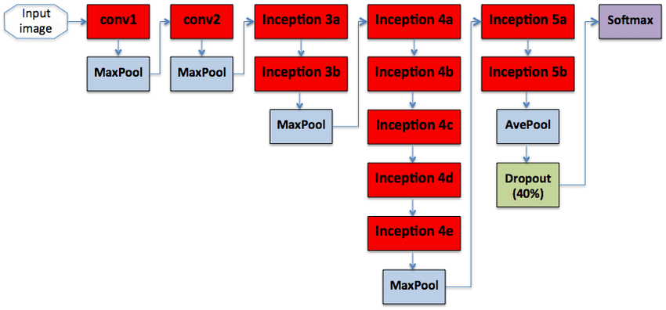
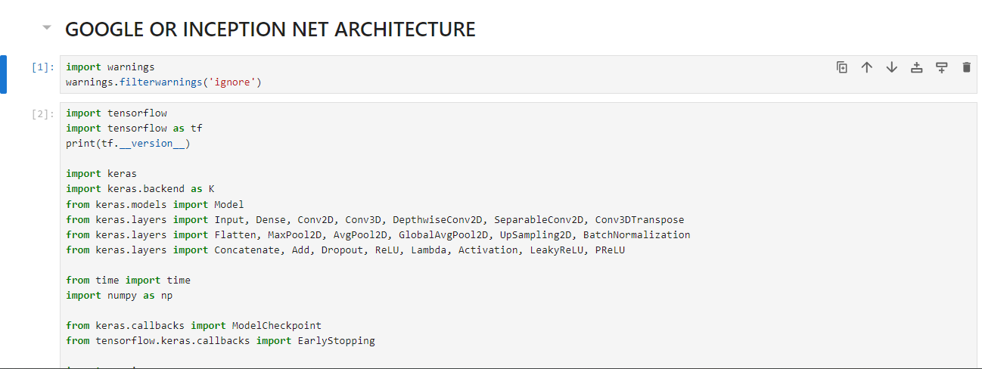
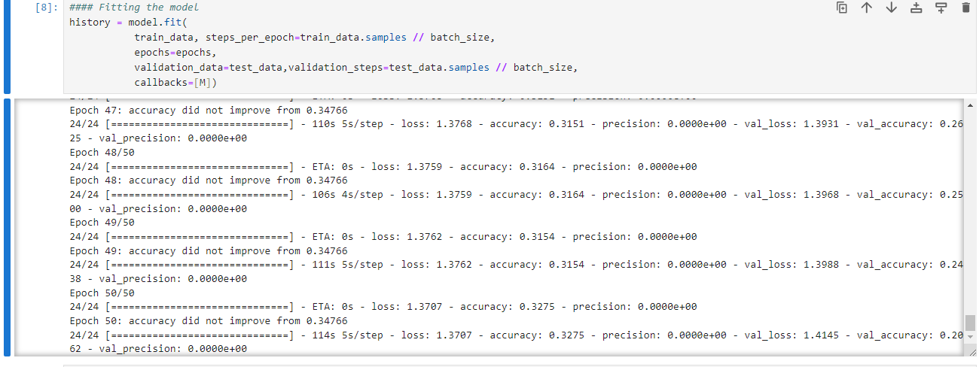
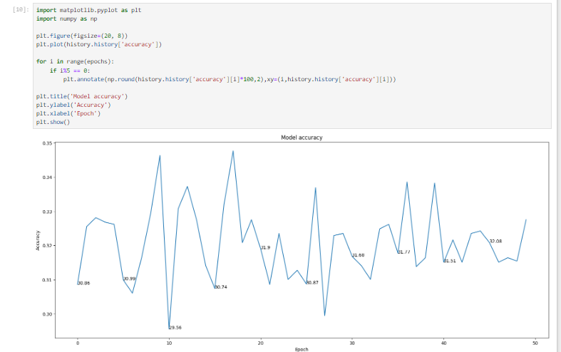

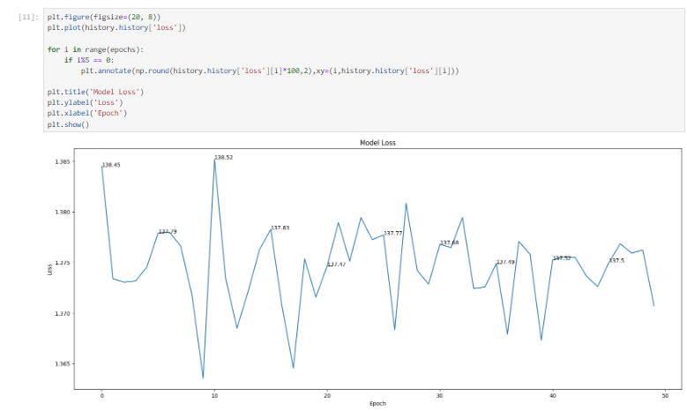

2. LENET:
The LeNet architecture is a pioneering convolutional neural network (CNN) architecture developed by Yann LeCun and his colleagues in the early 1990s. It played a crucial role in the advancement of deep learning and was specifically designed for handwritten digit recognition tasks, such as recognizing digits in checks and postal addresses. LeNet laid the foundation for modern CNNs and their applications in image recognition and computer vision tasks.
The LeNet architecture consists of the following layers:
Input Layer: This layer accepts the input image, which is typically a grayscale image of a handwritten digit. The input images are usually of size 32x32 pixels.
Convolutional Layers: LeNet uses two convolutional layers to extract features from the input images. Each convolutional layer applies convolutional filters (also called kernels) to the input image, capturing different patterns and features. These filters slide over the image to create feature maps.
Subsampling (Pooling) Layers: After each convolutional layer, a subsampling layer (also known as a pooling layer) is applied to reduce the spatial dimensions of the feature maps and help in retaining important information while reducing computation.
Fully Connected Layers: The subsampled feature maps are then flattened and passed through fully connected layers, which are traditional neural network layers. These layers are responsible for making classification decisions based on the extracted features.
Output Layer: The final fully connected layer produces the output of the network, which represents the predicted class probabilities. For handwritten digit recognition, this would typically involve 10 output nodes, each corresponding to a digit class (0 to 9).
LeNet was designed before the deep learning era as we know it today, so it has fewer layers compared to modern architectures like ResNet, VGG, or Inception. However, its fundamental design principles, including the use of convolutional and pooling layers, inspired the development of more complex CNN architectures. LeNet demonstrated the potential of neural networks in handling image recognition tasks and played a pivotal role in the resurgence of interest in neural networks during the early 2000s.

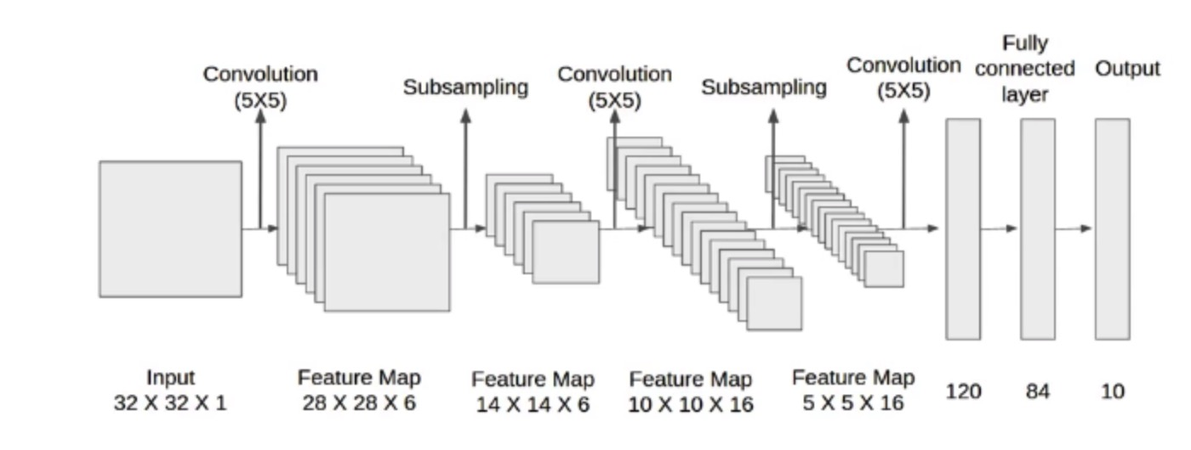

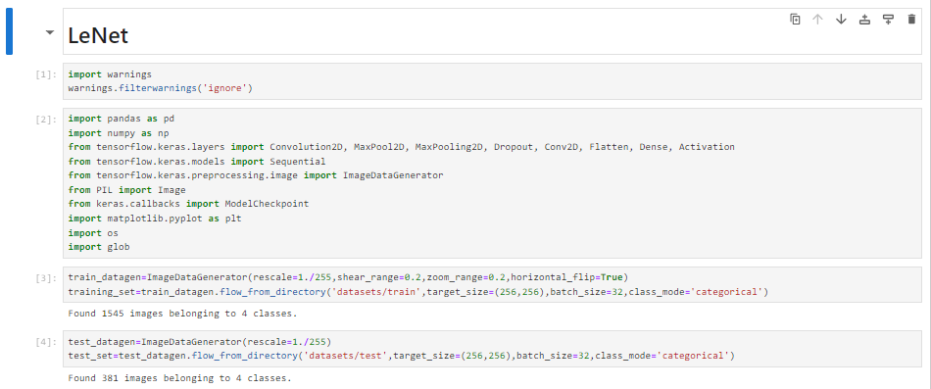
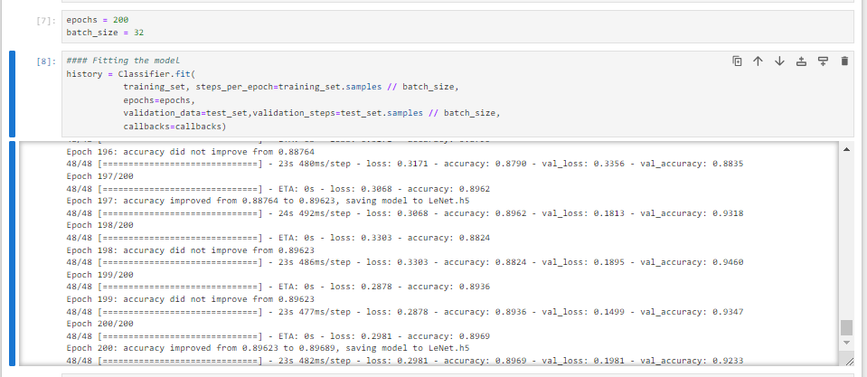
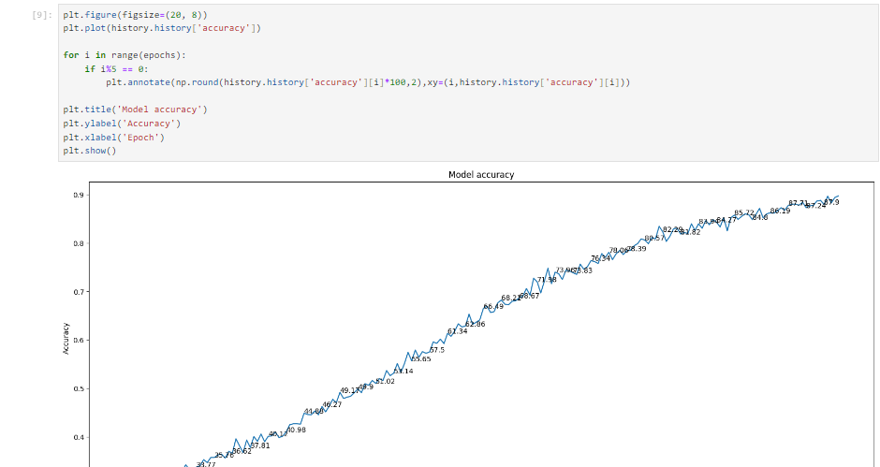
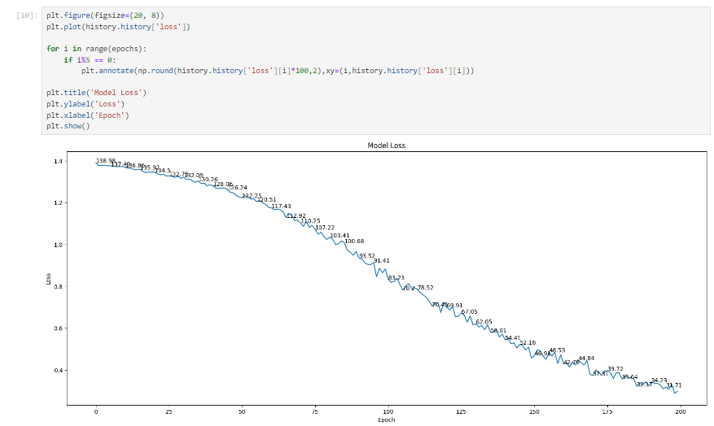

SPINE STENOSIS CLASSIFICATION IDENTIFICATION:
We give input image using keras pre-processing package. That input Image converted into array value using pillow and image to array function package. It classifies what are the spine stenosis. Then we have to detection our spine stenosis using detection function.

Given dataset

Input image

Feature Extractions

CNN Model

Spine stenosis Classification

The Spine stenosis Classification recognition method is based on a two-channel architecture that is able to recognize classification of Spine stenosis Classification. The Spine stenosis Classification images are used as the input into the inception layer of the CNN. The Training phase involves the feature extraction and classification using convolution neural network.

LIST OF MODULES:
1. Manual Net
2. Google Net
3. Lenet Net
4. Deploy

MODULE DESCRIPTION
IMPORT THE GIVEN IMAGE FROM DATASET:

We have to import our data set using keras preprocessing image data generator function also we create size, rescale, range, zoom range, horizontal flip. Then we import our image dataset from folder through the data generator function. Here we set train, test, and validation also we set target size, batch size and class-mode from this function we have to train using our own created network by adding layers of CNN.

TO TRAIN THE MODULE BY GIVEN IMAGE DATASET:
To train our dataset using classifier and fit generator function also we make training steps per epoch’s then total number of epochs, validation data and validation steps using this data we can train our dataset.

MANUAL ARCHITECTURE :
A Convolutional Neural Network (ConvNet/CNN) is a Deep Learning algorithm which can take in an input image, assign importance (learnable weights and biases) to various aspects/objects in the image and be able to differentiate one from the other. The pre-processing required in a ConvNet is much lower as compared to other classification algorithms. While in primitive methods filters are hand-engineered, with enough training, ConvNets have the ability to learn these filters/characteristics. The architecture of a ConvNet is analogous to that of the connectivity pattern of Neurons in the Human disease and was inspired by the organization of the Visual Cortex. Individual neurons respond to stimuli only in a restricted region of the visual field known as the Receptive Field. Their network consists of four layers with 1,024 input units, 256 units in the first hidden layer, eight units in the second hidden layer, and two output units.
Input Layer:
Input layer in CNN contain image data. Image data is represented by three dimensional matrixes. It needs to reshape it into a single column. Suppose you have image of dimension 28 x 28 =784, it need to convert it into 784 x 1 before feeding into input.

Convo Layer:
Convo layer is sometimes called feature extractor layer because features of the image are get extracted within this layer. First of all, a part of image is connected to Convo layer to perform convolution operation as we saw earlier and calculating the dot product between receptive field (it is a local region of the input image that has the same size as that of filter) and the filter. Result of the operation is single integer of the output volume. Then the filter over the next receptive field of the same input image by a Stride and do the same operation again. It will repeat the same process again and again until it goes through the whole image. The output will be the input for the next layer.

Pooling Layer:

Pooling layer is used to reduce the spatial volume of input image after convolution. It is used between two convolution layers. If it applies FC after Convo layer without applying pooling or max pooling, then it will be computationally expensive. So, the max pooling is only way to reduce the spatial volume of input image. It has applied max pooling in single depth slice with Stride of 2. It can observe the 4 x 4 dimension input is reducing to 2 x 2 dimensions.

Fully Connected Layer (FC):
Fully connected layer involves weights, biases, and neurons. It connects neurons in one layer to neurons in another layer. It is used to classify images between different categories by training.

Softmax / Logistic Layer:
Softmax or Logistic layer is the last layer of CNN. It resides at the end of FC layer. Logistic is used for binary classification and softmax is for multi-classification.

Output Layer:
Output layer contains the label which is in the form of one-hot encoded. Now you have a good understanding of CNN.

Libraries Required:
- tensorflow: Just to use the tensor board to compare the loss and adam curve our result data or obtained log.
- keras: To pre-process the image dataset.
- matplotlib: To display the result of our predictive outcome.
- os: To access the file system to read the image from the train and test directory from our machines.

TensorFlow:
TensorFlow is a Python library for fast numerical computing created and released by Google. It is a foundation library that can be used to create Deep Learning models directly or by using wrapper libraries that simplify the process built on top of TensorFlow.
TensorFlow is a software library or framework, designed by the Google team to implement machine learning and deep learning concepts in the easiest manner. It combines the computational algebra of optimization techniques for easy calculation of many mathematical expressions.
Let us now consider the following important features of TensorFlow −
- It includes a feature of that defines, optimizes and calculates mathematical expressions easily with the help of multi-dimensional arrays called tensors.
- It includes a programming support of deep neural networks and machine learning techniques.
- It includes a high scalable feature of computation with various data sets.
- TensorFlow uses GPU computing, automating management. It also includes a unique feature of optimization of same memory and the data used.

Keras:
Keras runs on top of open source machine libraries like TensorFlow, Theano or Cognitive Toolkit (CNTK). Theano is a python library used for fast numerical computation tasks. TensorFlow is the most famous symbolic math library used for creating neural networks and deep learning models. TensorFlow is very flexible and the primary benefit is distributed computing. CNTK is deep learning framework developed by Microsoft. It uses libraries such as Python, C#, C++ or standalone machine learning toolkits. Theano and TensorFlow are very powerful libraries but difficult to understand for creating neural networks.
Keras is based on minimal structure that provides a clean and easy way to create deep learning models based on TensorFlow or Theano. Keras is designed to quickly define deep learning models. Well, Keras is an optimal choice for deep learning applications.

Features
Keras leverages various optimization techniques to make high level neural network API easier and more performant. It supports the following features −
- Consistent, simple and extensible API.
- Minimal structure - easy to achieve the result without any frills.
- It supports multiple platforms and backends.
- It is user friendly framework which runs on both CPU and GPU.
- Highly scalability of computation.

Matplotlib:
Matplotlib is one of the most popular Python packages used for data visualization. It is a cross-platform library for making 2D plots from data in arrays. Matplotlib is written in Python and makes use of NumPy, the numerical mathematics extension of Python. It provides an object-oriented API that helps in embedding plots in applications using Python GUI toolkits such as PyQt, WxPythonotTkinter. It can be used in Python and IPython shells, Jupyter notebook and web application servers also.
Matplotlib has a procedural interface named the Pylab, which is designed to resemble MATLAB, a proprietary programming language developed by MathWorks. Matplotlib along with NumPy can be considered as the open source equivalent of MATLAB.
os:
The OS module in Python comes with various functions that enables developers to interact with the Operating system that they are currently working on. In this article we’ll be learning mainly to create and delete a directory/folder, rename a directory and even basics of file handling.
Python OS module provides the facility to establish the interaction between the user and the operating system. It offers many useful OS functions that are used to perform OS-based tasks and get related information about operating system.
The OS comes under Python's standard utility modules. This module offers a portable way of using operating system dependent functionality.

DEPLOY
Deploying the model in Django Framework and predicting output
In this module the trained deep learning model is converted into hierarchical data format file (.h5 file) which is then deployed in our django framework for providing better user interface and predicting the output.

30.1 Django
Django is a high-level Python web framework that enables rapid development of secure and maintainable websites. Built by experienced developers, Django takes care of much of the hassle of web development, so you can focus on writing your app without needing to reinvent the wheel. It is free and open source, has a thriving and active community, great documentation, and many options for free and paid-for support.
Maintainable
Django code is written using design principles and patterns that encourage the creation of maintainable and reusable code. In particular, it makes use of the Don't Repeat Yourself (DRY) principle so there is no unnecessary duplication, reducing the amount of code. Django also promotes the grouping of related functionality into reusable "applications" and, at a lower level, groups related code into modules (along the lines of the Model View Controller (MVC) pattern).
Portable
Django is written in Python, which runs on many platforms. That means that you are not tied to any particular server platform, and can run your applications on many flavours of Linux, Windows, and Mac OS X. Furthermore, Django is well-supported by many web hosting providers, who often provide specific infrastructure and documentation for hosting Django sites.
Versatile:
Django can be (and has been) used to build almost any type of website — from content management systems and wikis, through to social networks and news sites. It can work with any client-side framework, and can deliver content in almost any format (including HTML, RSS feeds, JSON, XML, etc). The site you are currently reading is built with Django!
Internally, while it provides choices for almost any functionality you might want (e.g. several popular databases, templating engines, etc.), it can also be extended to use other components if needed.

Secure:
- Django helps developers avoid many common security mistakes by providing a framework that has been engineered to "do the right things" to protect the website automatically. For example, Django provides a secure way to manage user accounts and passwords, avoiding common mistakes like putting session information in cookies where it is vulnerable (instead cookies just contain a key, and the actual data is stored in the database) or directly storing passwords rather than a password hash.
A password hash is a fixed-length value created by sending the password through a cryptographic hash function. Django can check if an entered password is correct by running it through the hash function and comparing the output to the stored hash value. However due to the "one-way" nature of the function, even if a stored hash value is compromised it is hard for an attacker to work out the original password.
Django enables protection against many vulnerabilities by default, including SQL injection, cross-site scripting, cross-site request forgery and clickjacking (see Website security for more details of such attacks).

Scalable:
Django uses a component-based “shared-nothing” architecture (each part of the architecture is independent of the others, and can hence be replaced or changed if needed). Having a clear separation between the different parts means that it can scale for increased traffic by adding hardware at any level: caching servers, database servers, or application servers. Some of the busiest sites have successfully scaled Django to meet their demands (e.g. Instagram and Disqus, to name just two).

Maintainable:
Django code is written using design principles and patterns that encourage the creation of maintainable and reusable code. In particular, it makes use of the Don't Repeat Yourself (DRY) principle so there is no unnecessary duplication, reducing the amount of code. Django also promotes the grouping of related functionality into reusable "applications" and, at a lower level, groups related code into modules (along the lines of the Model View Controller (MVC) pattern).

Portable:
Django is written in Python, which runs on many platforms. That means that you are not tied to any particular server platform, and can run your applications on many flavours of Linux, Windows, and Mac OS X. Furthermore, Django is well-supported by many web hosting providers, who often provide specific infrastructure and documentation for hosting Django sites.

HTML:
HTML stands for HyperText Markup Language. It is used to design web pages using a markup language. HTML is the combination of Hypertext and Markup language. Hypertext defines the link between the web pages. A markup language is used to define the text document within tag which defines the structure of web pages. This language is used to annotate (make notes for the computer) text so that a machine can understand it and manipulate text accordingly. Most markup languages (e.g. HTML) are human-readable. The language uses tags to define what manipulation has to be done on the text.

Basic Construction of an HTML Page
These tags should be placed underneath each other at the top of every HTML page that you create.



<!DOCTYPE html> — This tag specifies the language you will write on the page. In this case, the language is HTML 5.
<html> — This tag signals that from here on we are going to write in HTML code.
<head> — This is where all the metadata for the page goes — stuff mostly meant for search engines and other computer programs.
<body> — This is where the content of the page goes.

Further Tags
Inside the <head> tag, there is one tag that is always included: <title>, but there are others that are just as important:
<title>
This is where we insert the page name as it will appear at the top of the browser window or tab.
<meta>
This is where information about the document is stored: character encoding, name (page context), description.

HeadTag
<head>
<title>My First Webpage</title>
<meta charset="UTF-8">
<meta name="description" content="This field contains information about your page. It is usually around two sentences long.">.
<meta name="author" content="Conor Sheils">
</header>

Adding Content
Next, we will make <body> tag.
The HTML <body> is where we add the content which is designed for viewing by human eyes.
This includes text, images, tables, forms and everything else that we see on the internet each day.

How to Add HTML Headings To Your Web Page
In HTML, headings are written in the following elements:
- <h1>
  - <h2>
    - <h3>
      - <h4>
        - <h5>
          - <h6>
As you might have guessed <h1> and <h2> should be used for the most important titles, while the remaining tags should be used for sub-headings and less important text.
Search engine bots use this order when deciphering which information is most important on a page.

Creating Your Heading
Let’s try it out. On a new line in the HTML editor, type:
<h1>Welcome to My Page</h1>
And hit save. We will save this file as “index.html” in a new folder called “my webpage.”
The Moment of Truth: Click the newly saved file and your first ever web page should open in your default browser. It may not be pretty it’s yours… all yours. *Evil laugh*

Add Text In HTML
Adding text to our HTML page is simple using an element opened with the tag <p> which creates a new paragraph. We place all of our regular text inside the element <p>.
Element | Meaning | Purpose
<b> | Bold | Highlight important information
<strong> | Strong | Similarly to bold, to highlight key text
<i> | Italic | To denote text
<em> | Emphasised Text | Usually used as image captions
<mark> | Marked Text | Highlight the background of the text
<small> | Small Text | To shrink the text
<strike> | Striked Out Text | To place a horizontal line across the text
<u> | Underlined Text | Used for links or text highlights
<ins> | Inserted Text | Displayed with an underline to show an inserted text
<sup> | Superscript Text | Another typographical presentation style
When we write text in HTML, we also have a number of other elements we can use to control the text or make it appear in a certain way.

Add Links In HTML
As you may have noticed, the internet is made up of lots of links.
Almost everything you click on while surfing the web is a link takes you to another page within the website you are visiting or to an external site.
Links are included in an attribute opened by the <a> tag. This element is the first that we’ve met which uses an attribute and so it looks different to previously mentioned tags.
<a href="http://www.google.com">Google</a>
Image Tag
In today’s modern digital world, images are everything. The <img> tag has everything you need to display images on your site. Much like the <a> anchor element, <img> also contains an attribute.
The attribute features information for your computer regarding the source, height, width and alt text of the image
<img src="yourimage.jpg" alt="Describe the image" height="X" width="X">

CSS:
CSS stands for Cascading Style Sheets. It is the language for describing the presentation of Web pages, including colours, layout, and fonts, thus making our web pages presentable to the users.
CSS is designed to make style sheets for the web. It is independent of HTML and can be used with any XML-based markup language. Now let’s try to break the acronym:
- Cascading: Falling of Styles
- Style: Adding designs/Styling our HTML tags
- Sheets: Writing our style in different documents

CSS Syntax
Selector {
Property 1 : value;
Property 2 : value;
Property 3 : value;
}
For example:
h1
{
Color: red;
Text-align: center;
}
#unique
{
color: green;
}
- Selector: selects the element you want to target
- Always remains the same whether we apply internal or external styling
- There are few basic selectors like tags, id’s, and classes
- All forms this key-value pair
- Keys: properties(attributes) like color, font-size, background, width, height,etc
- Value: values associated with these properties

CSS Comment
- Comments don’t render on the browser
- Helps to understand our code better and makes it readable.
- Helps to debug our code
- Two ways to comment:
  - Single line

CSS How-To
- There are 3 ways to write CSS in our HTML file.
  - Inline CSS
  - Internal CSS
  - External CSS
- Priority order
Inline > Internal > External

Inline CSS
- Before CSS this was the only way to apply styles
- Not an efficient way to write as it has a lot of redundancy
- Self-contained
- Uniquely applied on each element
- The idea of separation of concerns was lost
- Example:
<h3 style=” color:red”> Have a great day </h3>
<p style =” color: green”> I did this , I did that </p>

Internal CSS
- With the help of style tag, we can apply styles within the HTML file
- Redundancy is removed
- But the idea of separation of concerns still lost
- Uniquely applied on a single document
- Example:
< style>
h1{
color:red;
}
</style>
<h3> Have a great day </h3>

External CSS
- With the help of <link> tag in the head tag, we can apply styles
- Reference is added
- File saved with .css extension
- Redundancy is removed
- The idea of separation of concerns is maintained
- Uniquely applied to each document
- Example:
<head>
<link rel=”stylesheet” type=”text/css” href=”name of the Css file”>
</head>
h1{
color:red; //.css file
}

CSS Selectors
- The selector is used to target elements and apply CSS
- Three simple selectors
  - Element Selector
  - Id Selector
  - Class Selector
- Priority of Selectors

CSS Colors
- There are different colouring schemes in CSS
- RGB-This starts with RGB and takes 3 parameter
- HEX-Hex code starts with # and comprises of 6 numbers which are further divided into 3 sets
- RGBA-This starts with RGB and takes 4 parameter

CSS Background
- There are different ways by which CSS can have an effect on HTML elements
- Few of them are as follows:
  - Color – used to set the color of the background
  - Repeat – used to determine if the image has to repeat or not and if it is repeating then how it should do that
  - Image – used to set an image as the background
  - Position – used to determine the position of the image
  - Attachment – It basically helps in controlling the mechanism of scrolling

CSS BoxModel
- Every element in CSS can be represented using the BOX model
- It allows us to add a border and define space between the content
- It helps the developer to develop and manipulate the elements
- It consists of 4 edges
  - Content edge – It comprises of the actual content
  - Padding edge – It lies in between content and border edge
  - Border edge – Padding is followed by the border edge
Margin edge – It is an outside border and controls the margin of the element.

CODING:
Module 1:
import warnings
warnings.filterwarnings('ignore')
import pandas as pd
import numpy as np
from PIL import Image
import tensorflow as tf
from tensorflow.keras.layers import Activation, MaxPooling2D, MaxPool2D, Dropout, Dense, Convolution2D, Conv2D, Flatten
from keras.preprocessing.image import ImageDataGenerator
from tensorflow.keras.models import Sequential
from tensorflow.keras.callbacks import ModelCheckpoint
import matplotlib.pyplot as plt
import os
import glob
mild='datasets/train/mild'
moderate='datasets/train/moderate'
normal='datasets/train/normal'
severe='datasets/train/severe'
def plot_images(item_dir, n=6):
all_item_dir = os.listdir(item_dir)
item_files = [os.path.join(item_dir, file) for file in all_item_dir][:n]

plt.figure(figsize=(80, 40))
for idx, img_path in enumerate(item_files):
plt.subplot(3, n, idx+1)
img = plt.imread(img_path)
plt.imshow(img, cmap='gray')
plt.axis('off')

plt.tight_layout()
def Images_details_Print_data(data, path):
print(" ====== Images in: ", path)
for k, v in data.items():
print("%s:\t%s" % (k, v))

def Images_details(path):
files = [f for f in glob.glob(path + "**/*.*", recursive=True)]
data = {}
data['images_count'] = len(files)
data['min_width'] = 10**100 # No image will be bigger than that
data['max_width'] = 0
data['min_height'] = 10**100 # No image will be bigger than that
data['max_height'] = 0

for f in files:
im = Image.open(f)
width, height = im.size
data['min_width'] = min(width, data['min_width'])
data['max_width'] = max(width, data['max_height'])
data['min_height'] = min(height, data['min_height'])
data['max_height'] = max(height, data['max_height'])

Images_details_Print_data(data, path)
print("")
print("Trainned data for mild:")
print("")
Images_details(mild)
print("")
plot_images(mild, 10)
print("")
print("Trainned data for moderate:")
print("")
Images_details(moderate)
print("")
plot_images(moderate, 10)
print("")
print("Trainned data for normal:")
print("")
Images_details(normal)
print("")
plot_images(normal, 10)
print("")
print("Trainned data for severe:")
print("")
Images_details(severe)
print("")
plot_images(severe, 10)
train_datagen=ImageDataGenerator(rescale=1./255,shear_range=0.2,zoom_range=0.2,horizontal_flip=True)
training_set=train_datagen.flow_from_directory('datasets/train',target_size=(256,256),batch_size=32,class_mode='categorical')
train_datagen=ImageDataGenerator(rescale=1./255,shear_range=0.2,zoom_range=0.2,horizontal_flip=True)
test_set=train_datagen.flow_from_directory('datasets/test',target_size=(256,256),batch_size=32,class_mode='categorical')
Classifier=Sequential()
Classifier.add(Convolution2D(32,(3,3),input_shape=(256,256,3),activation='relu'))
Classifier.add(MaxPooling2D(pool_size=(2,2)))
Classifier.add(Flatten())
Classifier.add(Dense(38, activation='relu'))
Classifier.add(Dense(4, activation='softmax'))
Classifier.compile(optimizer='rmsprop',loss='categorical_crossentropy',metrics=['accuracy'])
epochs = 10
batch_size = 64
#### Fitting the model
history = Classifier.fit(
training_set, steps_per_epoch=training_set.samples // batch_size,
epochs=epochs,
validation_data=test_set,validation_steps=test_set.samples // batch_size)
import matplotlib.pyplot as plt
import numpy as np

plt.figure(figsize=(20, 8))
plt.plot(history.history['accuracy'])

for i in range(epochs):
if i%5 == 0:
plt.annotate(np.round(history.history['accuracy'][i]*100,2),xy=(i,history.history['accuracy'][i]))

plt.title('Model accuracy')
plt.ylabel('Accuracy')
plt.xlabel('Epoch')
plt.show()
plt.figure(figsize=(20, 8))
plt.plot(history.history['loss'])

for i in range(epochs):
if i%5 == 0:
plt.annotate(np.round(history.history['loss'][i]*100,2),xy=(i,history.history['loss'][i]))

plt.title('Model Loss')
plt.ylabel('Loss')
plt.xlabel('Epoch')
plt.show()

Module 2:
## GOOGLE OR INCEPTION NET ARCHITECTURE
import warnings
warnings.filterwarnings('ignore')
import tensorflow
import tensorflow as tf
print(tf.__version__)

import keras
import keras.backend as K
from keras.models import Model
from keras.layers import Input, Dense, Conv2D, Conv3D, DepthwiseConv2D, SeparableConv2D, Conv3DTranspose
from keras.layers import Flatten, MaxPool2D, AvgPool2D, GlobalAvgPool2D, UpSampling2D, BatchNormalization
from keras.layers import Concatenate, Add, Dropout, ReLU, Lambda, Activation, LeakyReLU, PReLU

from time import time
import numpy as np

from keras.callbacks import ModelCheckpoint
from tensorflow.keras.callbacks import EarlyStopping

import warnings
warnings.filterwarnings('ignore')
from tensorflow.keras.preprocessing.image import ImageDataGenerator

train=ImageDataGenerator(rescale=1./255,shear_range=0.2,zoom_range=0.2,horizontal_flip=True,validation_split = 0.2)
train_data=train.flow_from_directory(directory = 'datasets/train',target_size=(224,224),
batch_size=32,class_mode='categorical')
test=ImageDataGenerator(rescale=1./255)
test_data=test.flow_from_directory(directory = 'datasets/test',target_size=(224,224),
batch_size=32,class_mode='categorical')
def googlenet(input_shape, n_classes):

def inception_block(x, f):
t1 = Conv2D(f[0], 1, activation='relu')(x)

t2 = Conv2D(f[1], 1, activation='relu')(x)
t2 = Conv2D(f[2], 3, padding='same', activation='relu')(t2)

t3 = Conv2D(f[3], 1, activation='relu')(x)
t3 = Conv2D(f[4], 5, padding='same', activation='relu')(t3)

t4 = MaxPool2D(3, 1, padding='same')(x)
t4 = Conv2D(f[5], 1, activation='relu')(t4)

output = Concatenate()([t1, t2, t3, t4])
return output

input = Input(input_shape)

x = Conv2D(64, 7, strides=2, padding='same', activation='relu')(input)
x = MaxPool2D(3, strides=2, padding='same')(x)

x = Conv2D(64, 1, activation='relu')(x)
x = Conv2D(192, 3, padding='same', activation='relu')(x)
x = MaxPool2D(3, strides=2)(x)

x = inception_block(x, [64, 96, 128, 16, 32, 32])
x = inception_block(x, [128, 128, 192, 32, 96, 64])
x = MaxPool2D(3, strides=2, padding='same')(x)

x = inception_block(x, [192, 96, 208, 16, 48, 64])
x = inception_block(x, [160, 112, 224, 24, 64, 64])
x = inception_block(x, [128, 128, 256, 24, 64, 64])
x = inception_block(x, [112, 144, 288, 32, 64, 64])
x = inception_block(x, [256, 160, 320, 32, 128, 128])
x = MaxPool2D(3, strides=2, padding='same')(x)

x = inception_block(x, [256, 160, 320, 32, 128, 128])
x = inception_block(x, [384, 192, 384, 48, 128, 128])

x = AvgPool2D(7, strides=1)(x)
x = Dropout(0.4)(x)

x = Flatten()(x)
output = Dense(n_classes, activation='softmax')(x)

model = Model(input, output)
model.compile(optimizer='Adam',loss='categorical_crossentropy',metrics=['accuracy',tensorflow.keras.metrics.Precision()])
return model

input_shape = 224, 224, 3
n_classes = 4

K.clear_session()
model = googlenet(input_shape, n_classes)
model.summary()
model_path = "GOOGLE.h5"

from keras.callbacks import ModelCheckpoint

M = ModelCheckpoint(model_path, monitor='accuracy', verbose=1, save_best_only=True)
epochs = 50
batch_size = 64
#### Fitting the model
history = model.fit(
train_data, steps_per_epoch=train_data.samples // batch_size,
epochs=epochs,
validation_data=test_data,validation_steps=test_data.samples // batch_size,
callbacks=[M])
history.history.keys()
import matplotlib.pyplot as plt
import numpy as np

plt.figure(figsize=(20, 8))
plt.plot(history.history['accuracy'])

for i in range(epochs):
if i%5 == 0:
plt.annotate(np.round(history.history['accuracy'][i]*100,2),xy=(i,history.history['accuracy'][i]))

plt.title('Model accuracy')
plt.ylabel('Accuracy')
plt.xlabel('Epoch')
plt.show()
plt.figure(figsize=(20, 8))
plt.plot(history.history['loss'])

for i in range(epochs):
if i%5 == 0:
plt.annotate(np.round(history.history['loss'][i]*100,2),xy=(i,history.history['loss'][i]))

plt.title('Model Loss')
plt.ylabel('Loss')
plt.xlabel('Epoch')
plt.show()

Module 3:
# LeNet
import warnings
warnings.filterwarnings('ignore')
import pandas as pd
import numpy as np
from tensorflow.keras.layers import Convolution2D, MaxPool2D, MaxPooling2D, Dropout, Conv2D, Flatten, Dense, Activation
from tensorflow.keras.models import Sequential
from tensorflow.keras.preprocessing.image import ImageDataGenerator
from PIL import Image
from keras.callbacks import ModelCheckpoint
import matplotlib.pyplot as plt
import os
import glob
train_datagen=ImageDataGenerator(rescale=1./255,shear_range=0.2,zoom_range=0.2,horizontal_flip=True)
training_set=train_datagen.flow_from_directory('datasets/train',target_size=(256,256),batch_size=32,class_mode='categorical')
test_datagen=ImageDataGenerator(rescale=1./255)
test_set=test_datagen.flow_from_directory('datasets/test',target_size=(256,256),batch_size=32,class_mode='categorical')
Classifier=Sequential()
Classifier.add(Convolution2D(32,3,3,input_shape=(256,256,3),activation='relu'))
Classifier.add(MaxPooling2D(pool_size=(2,2)))
Classifier.add(Convolution2D(128,3,3,activation='relu'))
Classifier.add(MaxPooling2D(pool_size=(2,2)))
Classifier.add(Flatten())
Classifier.add(Dense(256, activation='relu'))
Classifier.add(Dense(4, activation='softmax'))

Classifier.compile(optimizer='rmsprop',loss='categorical_crossentropy',metrics=['accuracy'])
Classifier.summary()
model_path = "LeNet.h5"

callbacks = [
ModelCheckpoint(model_path, monitor='accuracy', verbose=1, save_best_only=True)
]
epochs = 200
batch_size = 32
#### Fitting the model
history = Classifier.fit(
training_set, steps_per_epoch=training_set.samples // batch_size,
epochs=epochs,
validation_data=test_set,validation_steps=test_set.samples // batch_size,
callbacks=callbacks)
plt.figure(figsize=(20, 8))
plt.plot(history.history['accuracy'])

for i in range(epochs):
if i%5 == 0:
plt.annotate(np.round(history.history['accuracy'][i]*100,2),xy=(i,history.history['accuracy'][i]))

plt.title('Model accuracy')
plt.ylabel('Accuracy')
plt.xlabel('Epoch')
plt.show()
plt.figure(figsize=(20, 8))
plt.plot(history.history['loss'])

for i in range(epochs):
if i%5 == 0:
plt.annotate(np.round(history.history['loss'][i]*100,2),xy=(i,history.history['loss'][i]))

plt.title('Model Loss')
plt.ylabel('Loss')
plt.xlabel('Epoch')
plt.show()
import h5py
Classifier.save('Lenet.h5')
SCREEN SHOTS:
LANDING PAGE

Register Page
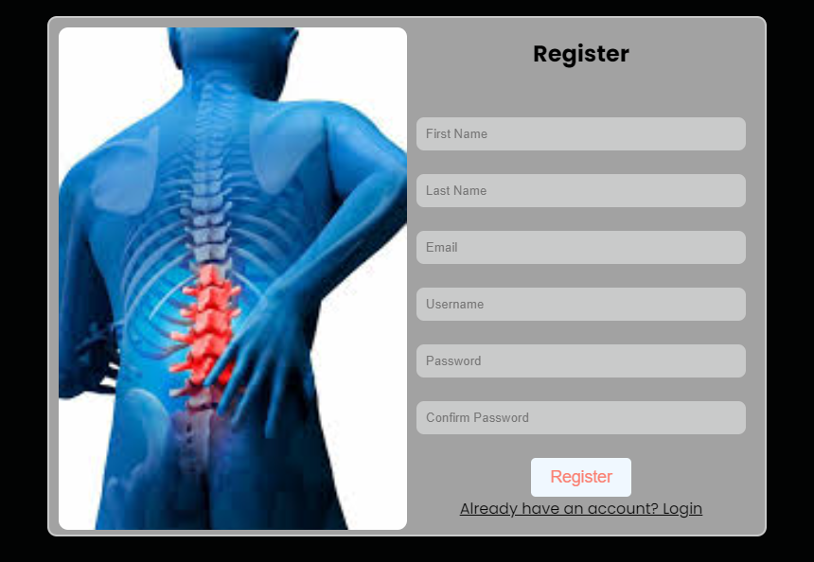

Login Page
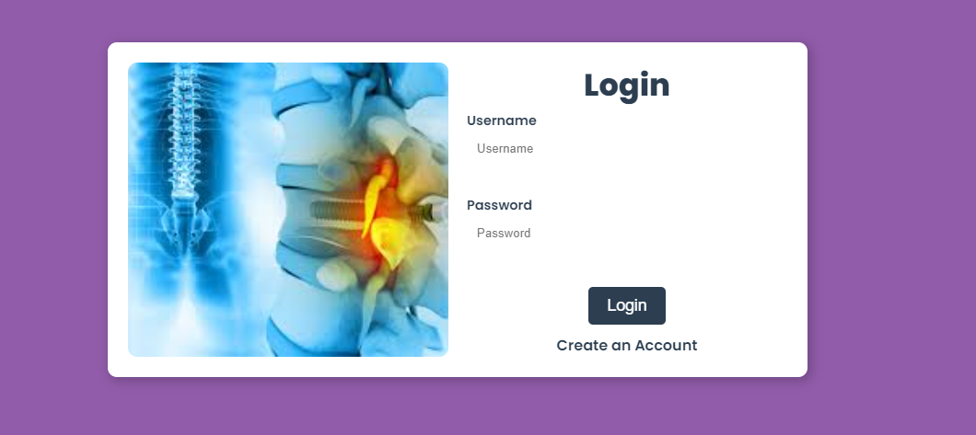

HOME PAGE:


INPUT PAGE
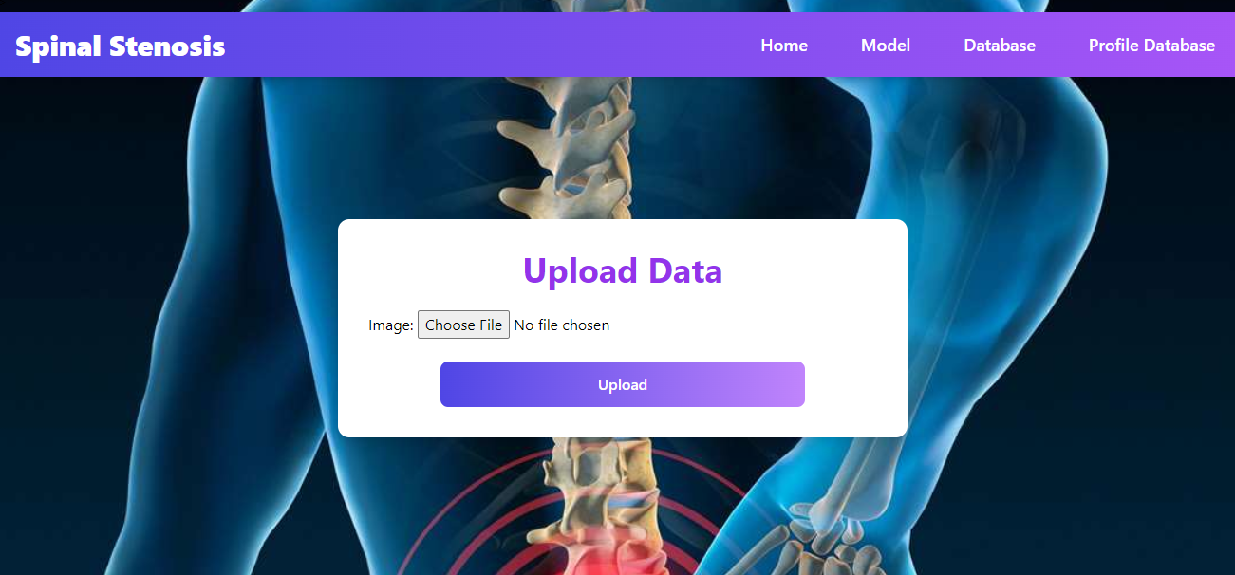

OUTPUT PAGE
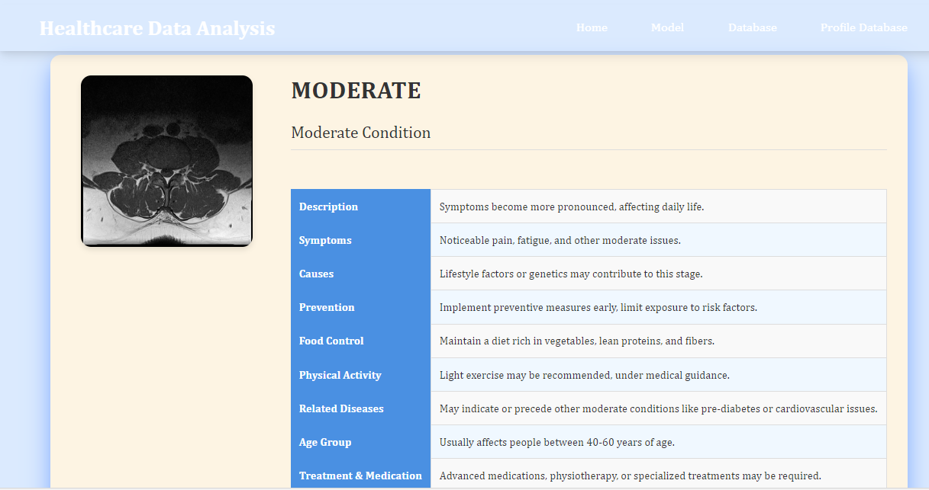

DATABASE PAGE
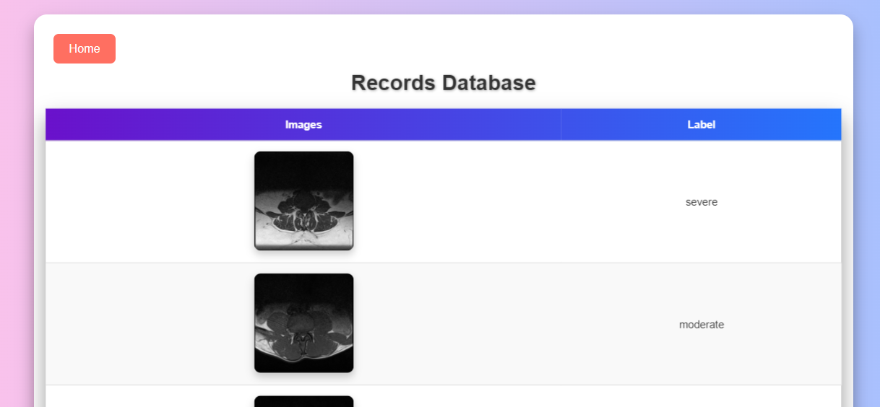

Conclusion:
In conclusion, the application of Convolutional Neural Network (CNN) architectures in SPINE STENOSIS classification has demonstrated significant strides towards improving diagnostic accuracy in musculoskeletal radiology. The robust feature extraction capabilities of CNNs have enabled the identification and categorization of diverse spine abnormalities with remarkable precision. This technological advancement holds promise for streamlining and enhancing the efficiency of diagnostic processes, ultimately contributing to more inform clinical decision-making. As the field continues to embrace automated image analysis, the integration of CNN architectures stands out as a pivotal step towards revolutionizing spine diagnostics and improving patient outcomes. Further research and refinement of these models promise continued advancements in the realm of automated musculoskeletal imaging analysis.

Future Work:

- Medical department wants to automate the detecting of SPINE STENOSIS from eligibility process (real time).
- To optimize the work to implement in cloud environment.

